

Children, Education and Skills

Children’s Safeguarding Standards Unit (CSSU)

Independent Reviewing Officer’s Annual Report

April 2022 – March 2023

Independent Reviewing Officers Annual Report

April 2021 to March 2022

Children, Education and Skills

**Children’s Safeguarding Standards Unit**

**Table of Contents**

1. Introduction 3

Purpose of Service and National Context 3

2. Role and Function of IROs in Newcastle 3

3. Staff Structure and Profile 4

4. Review of Progress 2022 – 2023 4

Context 4

Progress against priorities 5

Priority 1 – Voice of the Child 5

Priority 2 – People 7

Priority 3 – Practice and Systems 8

Priority 4 – Performance Management, Compliance and Quality Assurance 9

5. Children in Care 11

6. Child Protection 12

7.Child’s Voice 13

Advocacy 13

Mind of My Own (MOMO) 14

Independent Visitors 15

Children’s involvement in their reviews 15

8.Challenge and Escalation 17

8.Case Review and Escaltion Process. 18

9.Other areas of CSSU activity 18

Foster Carer Reviews 18

10.Private Fostering 19

11.Summary 20

12. Priorities 20

**Appendix 1 ................................................................................................................................22**

**Appendix 2** .............................................................................................................................................**25**

# **1.** **Introduction**

1.1 The Adoption and Children Act 2002 directs that the manager of the Independent Reviewing Officer (IRO) service ‘should produce an annual report for the scrutiny of members of the corporate parenting board[1]’.

1.2 This report covers the period April 2022 to March 2023 and provides data and evaluation relating to the IRO Service in Newcastle.

## **Purpose of Service and National Context**

1.3 Effective care planning is essential to achieve the best possible outcomes for children in care. In 2004, the role of ‘Independent Reviewing Officer’ (IRO) was established to monitor the way that local authorities implement plans for children in care and to ensure that the child’s wishes and feelings are fully considered. In April 2011, changes in government regulations and statutory guidance about care planning came into force, which strengthened the IRO’s role and provided detailed guidance in the ‘IRO Handbook’. The responsibility of the IRO changed from the management of the ‘Child in Care Review’ process to a wider role with responsibility for monitoring looked after children’s cases.

1.4 Newcastle City Council also applies the role of the IRO to all children with active Child Protection Plans.

# **2.** **Role and Function of** **IROs in Newcastle**

2.1 By providing independent oversight of children’s cases, IROs endeavour to ensure that all children receive high quality consistent care and support so that they are safeguarded, and their health and wellbeing are promoted.

2.2 The specific roles of IROs in Newcastle are listed below:

* Chairing initial child protection conferences and reviews
* Charing reviews for children in our care
* Charing reviews for our children placed for adoption
* Secure Accommodation Reviews for our children in secure accommodation
* The provision of independent oversight of all CP and Children in Care (CIC) cases between reviews and conferences
* The convening and chairing of reviews of Foster Carers
* Monitoring and reviewing all Private Fostering Arrangements
* The convening and chairing of Assessment, Intervention and Moving On (AIM2) meetings
* Chairing disruption meetings
* Contributing to single and multi-agency training
* Chairing some complex abuse meetings
* Oversight of the Mind of My Own consultation
* Promoting awareness and uptake of Young People’s Advocacy and Independent Visitors services

# **3.** **Staff Structure and Profile**

3.1 Responsibility for the activity and development of the Unit lies with the Service Manager for the Children’s Safeguarding Standards Unit, who reports to the Principal Advisor for Children’s Social Care. The IRO Team Manager provides line management support to 12 IROs and supports the development of the IRO Service. The IRO Team Manager reports to the Service Manager for the Children’s Standards Unit.

3.2 The current staffing structure includes:

* Service Manager, Children’s Safeguarding Standards Unit
* IRO Team Manager
* 15.5 FTE Independent Reviewing Officers

3.3 We have the following specialist roles:

* One IRO provides a dedicated review / oversight service to children placed for adoption
* One IRO undertakes reviews of all children subject to Private Fostering Arrangements
* 2 IROs provided a dedicated Foster Carer Review Service
* Three IROs have specialist disability experience
* One IRO has specialist experience of working with children and young people who display harmful sexual behaviour

# **4.** **Review of Progress 2022 – 2023**

## **Context**

4.1 The period from 2022 to 2023 was marked by change brought on by the pandemic and Newcastle’s continuing work with Leeds, implementing the Strengthening Families programme. 2022 saw the embedding of the relational and restorative approach that had helped us achieve a significant and safe reduction in the number of children with a Child Protection Plan. The changes were achieved by ensuring we worked with families to develop the right plans and interventions that would help them bring about the changes required in their lives. It also helped ensure that Child Protection Plans were used only for children facing risk of significant harm, and not to address more general worries or needs that should be supported though Child in Need (s.17) or Early Help arrangements.

4.2 The IRO Service also responded to the findings of the Ofsted[2] inspection of Children’s Services in late 2021. The inspectors concluded that “Independent reviewing officers (IROs) have competing workload demands, which have an impact on their capacity to provide effective challenge and ensure that written plans are always focused on the experience and progress of children”. In response the IRO Service recruited to two defined Foster Care Review IRO posts and piloted a desk top review approach for some foster carer reviews. This meant that Foster Carer Reviews could be managed separately from the work with children. The FCR specialist posts did not begin to operate until the end of this reporting period and as such the impact of this change will be covered in the Annual Report for 2023-24.

4.3 Children’s Social Care along with our key partners, Northumbria Police and the Northeast and Cumbria ICB, working through Newcastle Safeguarding Children Partnership, were required to support increasing numbers of children facing risk outside the home. Whilst these issues were not new, the scale of the challenge was and there was a need to develop our procedures, practices, and resources to work increasingly with children facing contextual risk. There were a small number of high-profile incidents which resulted in death or serious injury and understandably this was devastating for the children and families involved and a huge challenge for agencies and staff, when so much of what the Partnership had developed was focussed on supporting children facing risk in the home. This work has gathered pace in the current year and whilst it is reflected in this report, further evaluation will be completed for the subsequent report.

## **Progress against priorities**

4.4 The following section describes progress against our priorities during the period.

### **Priority 1 – Voice of the Child**

*Outcome – The work of all IROs will be informed by a full understanding of the child’s lived experience, wishes and feelings. This information will underpin improved outcomes for our children and contribute to the improvement of the service provided by IROs and the CSSU.*

4.5 Strengthening how we work with families by building trusting relationships has been a central part of Newcastle’s improvement journey. Our quality assurance work from 2021-22 had identified some inconsistencies in how IROs work with and support children in care as compared to children on a child protection plan. In short, there have been much clearer expectations for IROs to visit and form working relationships with children in care than there for children on child protection plans. This reflects statutory duties and the level of resourcing, but it meant IROs were rarely having significant contact with children on protection plans and this reduced our ability to bring their voice to the fore. Moreover, children were not routinely being invited to their child protection meetings, whilst children

in care were in most cases, central to the planning of their Child in Care Reviews. As such during the year a programme to ensure a more equitable distribution of IRO time was implemented. A key part of was possible due to the development of the 2 dedicated Foster Carer Review role. This has achieved change in how IRO’s perceive their role with child on protection plans and has brought improvement to the number of children with Child Protection plans that are taking part in their reviews and to a lesser extent, improvement in the number visited. The latter is still proving a challenge in terms of resourcing.

4.6 Whilst there have been some pressures created by staff turnover and staff absence due to illness the service has managed to maintain a high level of stability in terms of allocations, which means IROs continue to enjoy long term relationships with children in care. The stability of these relationships strengthens our ability to support the children participate fully in their reviews. It is key in helping the children have the confidence to shape their reviews. Over the year under review, we have achieved a participation rate of 98.2% and this includes improving performance for visiting children prior to their reviews. The service has endeavoured to move back towards face to face working as the method of preference, using virtual meetings and technology only for exceptions or for when a child has a expressed a wish to meet virtually.

4.7 During the year we continued to encourage IROs and other relevant staff across CSC to be more mindful about how children may be involved in their reviews. Where children cannot or choose not to attend reviews, we have seen improved evidence of direct work which brings the voice of the child to the fore of the review process. We have continued to promote the use of Mind of My Own and usage has improved. We continued to see improvements in children attending part or all their child protection meetings and 98.2% of children in care participating in their reviews.

4.8 During 2022-23 the service reviewed the strengthened decision-making arrangements agreed in the previous year to address the high number of meetings that are rearranged. It had been identified that meetings were often changed to meet the needs of professionals and that it was the professionals that agreed the new dates, times, and venues. CSSU, in agreement with Senior Managers across Children’s Social Care, agreed that no child’s meeting should be rescheduled without understanding the wishes and feelings of the child and family and once this was known the decision requires Service Manager agreement. The review found some improvement in the number of rearranged meetings but evidence of continuing difficulties. The number of rearranged meetings remained high and was seen to be impacting on key safeguarding and performance timescales. This led to an exercise whereby information about the number of changes and the impact of them was shared more directly with frontline staff, to raise their awareness and also to seek their views about why this happens. This remains an issue under review.

### **Priority 2 – People**

*Outcome – Children and young people will be safeguarded, and their welfare promoted through a robust, highly skilled, reflective effective IRO workforce with robust administrative support, working within a learning culture.*

4.9 The IRO Team Manager has a particular remit to promote learning and improvement across the service and her appointment has enabled a range of quality assurance processes to be developed. This includes increased use of audit and practice observations, robust management information and the development of staff development opportunities such as group supervision and bespoke training. Together, these approaches have strengthened management oversight of the service and provided greater assurance that children continue to be safeguarded and where there are difficulties with aspects of their plans, these are identified and addressed within the child’s timescale. Further information on learning identified through audit, observation and management information is addressed later in the report, in section 4.17 and 4.18.

4.10 The service has benefitted from the development of relational and restorative approaches to social work through our work with Leeds City Council. IROs have benefitted from bespoke training on relational practice that explored how they could strengthen care planning for children and ensure children remain at the heart of everything they do. They have had further opportunities to embed this learning in their work via workshops for ‘Re-think Formulation’ which helps practitioners reflect and explore new approaches to issues when working with families. This technique has also been adopted to help IROs and others understand why in some cases protection plans remain in place for periods beyond 15 months and it has proved effective in helping drive forward more effective plans to achieve safety and change.

4.11 A regional IRO focussed learning event took place during the year which provided a series of lunchtime learning sessions over a two-week period. This proved to be very well attended and practitioners evaluated the provision highly. This was alongside the standing training and development opportunities available to staff working for Newcastle City Council. The Edgehill training programme was paused during the year under review. However, this is set to be offered again in 2023-24 allowing a further four IROs to benefit from a dedicated IRO course delivered by Edgehill University. In total 12 IROs have already completed this training and the new cohort for 2023-24 should see all remaining IROs complete it.

4.12 During the year IRO Group Supervision was held monthly and was used to upskill IROs and provide the opportunity to reflect on local and national practice and learning from reviews, audits, and research. Sessions included the following:

* Evaluating and reflecting on the learning from the national reviews for Star and Arthur[3] and local reviews particularly where there are similarities in areas for improvement. See Appendix 2
* Strengthened our understanding of contextual safeguarding including the challenges and potential barriers to protecting children from exploitation and the importance of disruption activity
* The interface between Family Group Conferences, the ICPC, and Review Conference processes and between a family plan to keep a child safe and a child protection plan

### **Priority 3 – Practice and Systems**

*Outcome - Safeguarding* *children procedures and accompanying information reflect up to date processes, internal arrangements, and best practice in order to improve outcomes for our children.*

4.13 During the year under review CCSU reviewed an updated procedures relating to Foster Carer Reviews, Disruption Reviews, and the Designated Review Process. These core policies shape a large part of the Unit’s work, and the changes were driven by the need to continuously improve how we work with children, families, and colleagues to achieve the best possible outcomes. The Designated Review Process has now been replaced by Challenge and Support Conversations, which are based on the ‘Re-think Formulation’ approached developed through our work with Leeds. As we update our policies and procedures the Unit endeavours to ensure the principles of relational and restorative practice are embedded and promoted. As such, the work on Foster Carer Reviews aims to ensure that the voice of all parties is better heard at the review, so that decisions reached are based on the best understanding on the Carer’s work over the previous year. A Foster Carer Review Improvement plan is in place with the project group being led by CSSU.

4.14 In Spring 2022 CSSU conducted a multi-agency review of the Single Report for Child Protection Reviews. The review also involved consulting with families who had taken part in the child protection process. The single report was developed in response to learning about the experiences of families in child protection meetings, most notably delays in information and reports being shared with parents before meetings. This often meant parents had to read several reports at the start of meetings, denying them time to digest the information and an opportunity to prepare. The single report provides families with just one report 2 weeks in advance of the child protection review. The report is developed by the core group and the family to ensure all information is shared openly in advance and that there are no surprises. Families and professionals continued to report

that the single report improved the experience for families taking part in the meetings and allowing more time to develop effective support plans. Some concerns were identified by social workers who sometimes felt the single report was seen as their responsibility and this was addressed across the partnership.

4.15 CSSU, with support from colleagues in Information and Informatics, developed a comprehensive reporting system to help track the development and implementation of permanence plans for children in care. The system, which utilises a software package called Power BI, allows the user to access live information on children allowing CSSU to identify and track children for whom there is not agreed plan in place. We know from research that delays in agreeing plans can have serious detrimental impact on children in care. This tool enables IROs to monitor and track the development of plans and act where this has not happened. The tool has also supported the wider service in understanding timescales for developing and implementing plans and supported the service to address any systemic or practice-based obstacles. This tool has been developed over the year under review and CSSU now meet regularly with Service Managers for the Social Work Teams to help problem solve and address delay in the care planning process.

### **Priority 4 – Performance Management, Compliance and Quality Assurance**

*Outcome – Assurance is sought, evidenced, and challenged to demonstrate how the IRO service contributes to improved outcomes for our children and young people.*

4.16 Performance Management has been strengthened significantly through this year with the following activity being undertaken:

* Establishment of an IRO Score Card based on national and local practice issues to inform our improvement journey
* Monthly ‘Practice and Performance Conversations’ analysing data and performance information in evaluating the impact of our work
* Improvement in management oversight, tracking recording is up to date, actions have been taken and plans implemented
* A strengthened approach to independent scrutiny of child protection plans that have lasted for 15 months or more
* Audits of IRO activity and impact across children in care and child protection systems and services
* A compliance form is completed by IROs once they have conducted an ICPC or a Review Conference. During the year 643 compliance forms were completed by the Service and some of the key findings are contained later in this report

4.17 During the year further work was completed on children that have second and subsequent child protection plans. This has been a long-term issue within Newcastle, where between 20 to 25% of children with a Child Protection Plan have had one

previously. That raises the possibility that the initial plan did not lead to sufficient change in terms of the child’s lived experiences. The initial audit, completed in late 2020 identified that professionals can be too simplistic in their approach to working with families who have entrenched issues of drug and alcohol addiction, domestic violence, and long-term mental illness. There was too much reliance on parents self-reporting improvements without there being actual sustained change. Follow up audits have been conducted annually and the latest findings highlight some improvement achieved through the use of relational and restorative approaches. The establishment of these family relationships and networks meant that long term supports were put in place by families themselves, and this proved to be much more sustainable as the family support remained long after agency support had finished. This contributed to a safe reduction in the need for statutory intervention and allowed the reality of chronic difficulties to be addressed over time and outside the child protection process. However, the rate of second and subsequent plans has remained higher than desired and as such this will remain an area of work under review and further audit will be undertaken.

4.18 Other areas of learning from audit include:

* Improved evidence of plans that are child focused, engaging families and partners successfully and that are realistic, achievable, and timely
* Good evidence of IRO engagement and that they are listening to their children, using a variety of methods to do this depending on the needs of the child
* The need to improve consistency and quality of practice around focussed outcomes, with specific actions that provide a clear understanding of what needs to be achieved and within what timescale to minimise the risk of significant harm
* Ensuring IROs keep abreast of the child’s history as this may shape the child’s wishes and feelings in the present and the future.

4.19 The IRO Service was involved in the 2 Practice weeks held in 2022-2023 which took place in April and November 2022

Learning from the IRO Service highlighted some evidence of:

* + Relational practice by IROs with their families
  + Established and meaningful relationships between IROs and their families
  + Families feel respected and valued
  + Positive progress is identified and highlighted by IROs with their families
  + Children’s views are evidenced in the work of IROs

# **5.** **Children in Care**

5.1 Children in Care activity is measured using the number of children that are ‘looked after’ by the local authority at the end of the year and the number of children starting and ceasing being looked after during the year. All rates and statistics referred to in this section are taken from data collected internally within Newcastle City Council for 2022-23 and statistics published by the Department for Education for previous years.

On 31 March 2023 there were 649 Children in Care in Newcastle, down from 671 at the same time last year.

**649**

**Children Care**

Of the Children in Care in Newcastle 57% are male and 43% female. 81% are White (up from 77% last year) with the highest proportion being 15 years or over.

81%

White

**66% on**

**Full Care Order**

66% were in care under a Full Care Order (up 5% from last year), 15% under voluntary ‘Section 20’ arrangements (unchanged from last year). 13% are under an Interim Care Order (down 4%) and 6% are on a Placement Order down 2% from last year).

95% of children had their latest review within timescale which was a slight reduction from 2021-2022 levels. In the 6 weeks leading up to 31 March 2023, 73% of children had been seen by their social worker. This was a reduction on the previous year and is an issue that IROs raise with the relevant teams as appropriate.

**95%**

**Reviews in**

**time**

In the second half of 2022-23, 42% of children starting to be looked after had a primary need of abuse or neglect. 7% were unaccompanied asylum-seeking children (UASC). 3 of the 88 new Children in Care in this period were entering care for the second or subsequent time.

**42%**

**Abuse/**

**Neglect**

In the second half of 2022-23, 21% of the CYP who left care were subject to a Special Guardianship Order and 19% were adopted. 26% were reunified to their parents or to relatives (compared to 57% last year). This is a return to a more typical pattern after an unusually high percentage of SGOs and Adoption in 2020-21, presumably driven by the COVID-19 pandemic.

**26%**

**reunified**

At 31 March, 76% of CiC were in Foster placements and 70% were in in-house foster places. 5% had more than 2 placements in 2021-22 (similar to the previous year), but 70% had only one placement. 66% of children looked after continuously for 2.5 years have been in the same placement for 2 years or more. This is an improving situation for our children particularly given the pressures of the pandemic.

**75%**

**Foster**

**care**

# **6.** **Child Protection**

6.1 Child Protection activity is measured using the number of children on child protection plans at the end of the year and the number of children starting and ending plans during the year. All rates and statistics referred to in this section are taken from data collected internally within Newcastle City Council for 2022-23 and statistics published by the Department for Education for previous years.

On 31 March 2023 there were 334 children with a CP Plan in Newcastle. This is down from 350 at the end of 2021-22. Only 1 child had been on a plan for more than 2 years. This reduction is following the high numbers last year and the service’s response to implement a more relational and reflective approach to support social workers and IROs to move from a focus on concerns to that of risk of significant harm.

**334**

**CP Plans**

In the last 6 months of 2022-23 there were 66 new plans per 10,000 children aged under 17, this is down from 81 in 2021-22, and notably down from the previous two years (at 124 and 114). It is in line with our Statistical Neighbours.

**66 per 10,000**

**Starting**

Children on CP Plans in Newcastle are predominantly White (81%) with the highest proportion being 2 years old or younger. 20 unborn children were subject to a CP Plan on 31 March 2022.

**81%**

**White**

25% of the children starting a CP Plan in the last six months of 2022-23 had previously been the subject of a CP Plan. This is in line with last year and with statistical neighbour and national comparators.

**25%**

**Repeat**

**85%**

**Emotional abuse and Neglect**

85% of children are placed on CP Plans due to emotional abuse and/or neglect and this is reflective of similar trends across England.

**84%**

**visited**

On 31 March 2023 84% of children had been seen in the last 4 weeks. 50% of children had been seen alone.

Of the children that ceased to be the subject of a CP Plan the last six months of 2022-23 3% ended after a period of 2 years or more (which is a reduction of 9% since last year). The majority of CP Plans lasted between 6 and 24 months. 13% of plans ended after less than 3 months.

**3%**

**2+ years**

# **7.** **Child’s Voice**

## **Advocacy**

7.1 For 2022-2023 there were 72 referrals for Children’s Independent Advocacy. This is a slight decrease from the previous year when 79 referrals were made. Of the 72, 8 were related to children involved in the child protection process and the remainder were children in care.

7.2 In Newcastle advocacy is available to all children active to Children’s Social Care. IROs have a specific responsibility to ensure looked after children are aware of their right to access advocacy services and it is an issue that must be addressed at every child in care and child protection review. NYAS, the advocacy service provider, attended the IRO team meeting to discuss how service uptake might be improved. This led to an audit of child in care reviews to explore how clearly advocacy was being addressed and identified good practice was shared across the team and reinforced via group supervision.

7.3 It is a standing aspiration to increase the number for children accessing advocacy. This is a strong theme in many key national reports, such as The Review of Children’s Social Care, which highlighted the importance of children having independent advocacy support. To this end Newcastle is working with the advocacy provider to help raise awareness and take up of the service. Newcastle leads on a regional contract and when the contract was renewed, Newcastle was keen to ensure that the contract supported the core costs of providing an advocacy service, so that funds were made available to support promotional and publicity. The new contract went live in April 2022.

7.4 IROs complete a compliance form after every ICPC or Review Conference. This is one form per family using the youngest child as the subject that they make the responses on behalf of. Analysis of the compliance forms during this period identified that in most of these meetings the voice of the child is heard as set out below however the findings also indicate that we have more work to do.

**Was the Child/Children's Voice Heard?**

Yes (Blue) 576 which is 90%

No (Orange) 24 which is 7%

N/A (Green) 43 which is 4%

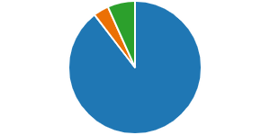

## **Mind of My Own (MOMO)**

7.4 All children active to Children’s Social Care (CSC) are supported to use the Mind of My Own participation app. All CSC staff can also access ‘workers’ accounts’ through which they can help younger children or others with additional needs to use MOMO to register their views and send messages to nominated people, including their IROs. MOMO enables children to share their views at a time of their choosing. The tool can also be used to support children in the assessment, planning and review processes. Children can express their views about what they wish, some examples of data collected is shown below for the period April 2022 to March 2023.

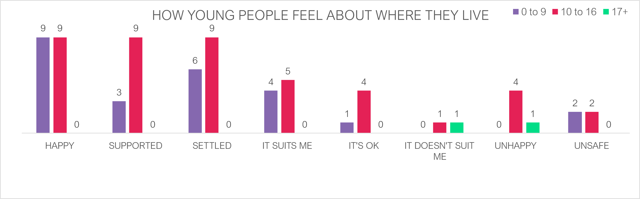

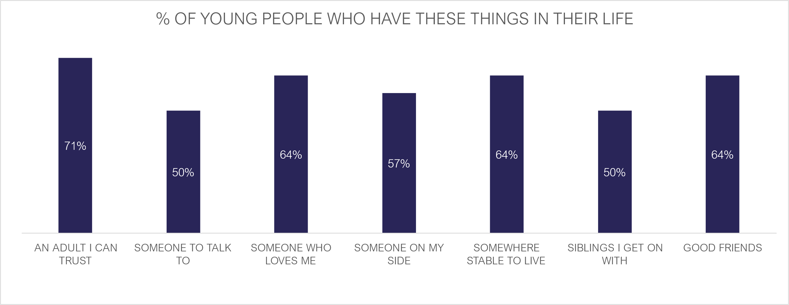

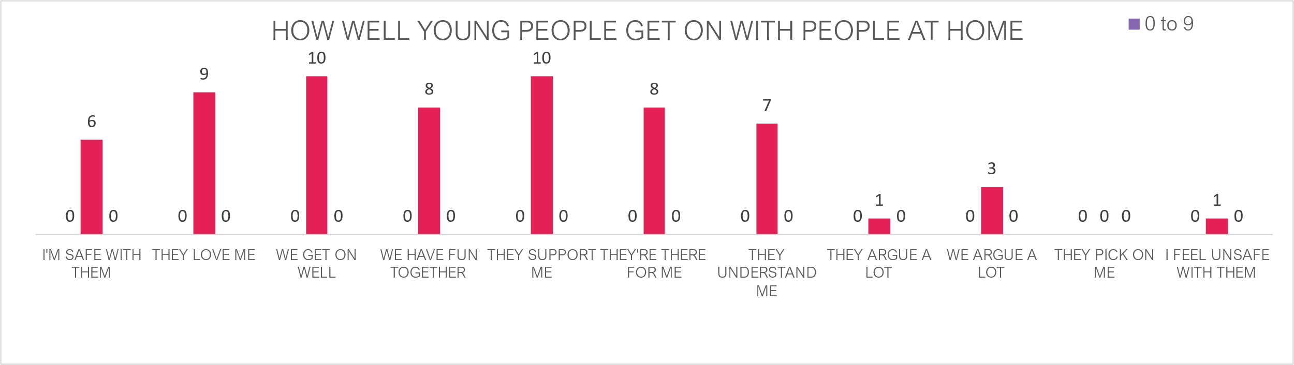

7.5 Most of the statements received have been positive and reflect the children’s satisfaction with their care arrangements. Where concerns have been identified this has been shared with relevant staff to ensure any issues can be explored and resolved.

7.6 There is a MOMO Steering Group which focusses on ensuring the service is used by as many children as possible to help staff use the system effectively with children, to support participation in the assessment, planning and review processes and to ensure the voice of the child and their lived experience is captured, understood, and used.

## **Independent Visitors**

7.7 This is a service provided to Children in Care intended to provide opportunities for positive activities but also for the young people to make positive relationships and develop their social skills. Children and young people can be matched with independent visitors for the duration of their childhood, meaning the relationship can last several years. During the year under review the provider of the Independent Visitor Service changed, following a tendering process. From November 2022, the provider has been NEPACS.

7.8 Whilst the number of children and young people taking up the service is low; practitioners are confident that those that require the service have been referred. At the year-end there were 7 young people matched, with a further 12 waiting to be matched. Newcastle and the other authorities in the regional contract are working with NEPACS to help strengthen their recruitment and ability to match children. Across the region some children have waited too long for this service. This will remain a key area of focus for IROs within their review and oversight functions.

## **Children’s involvement in their reviews**

7.9 Reviews are an important opportunity for Children in Care to have their say about the care that they receive. During 2022-23 95.9% of reviews happened in the statutory timescales which was a slight decrease on the previous year. This was primarily due to staffing issues in the social work teams and the IRO Service including numbers and sickness. As reported previously work was done with the social work teams, additional resources provided in the social work teams and the IRO service was fully staffed by May 2023. 98.2% of children participated in their review in some way. Appendix 1 sets out some snapshots of IRO records in respect of their engagement and contact with their children.

7.10 During 2022-23, IROs have been supported to undertake more reviews face to face. Virtual reviews are an option, should a child wish it, but there has been a strong desire to get back to face to face working, as it strengthens relationships, and they are at the core of Newcastle’s approach. We endeavour to offer children a choice of how they wish to take part in their meetings. Whilst it is our wish that most take place face to face, some children continue to prefer to take part via video call and this is respected.

7.11 ICPC and Review Conference compliance monitoring demonstrates that we still have some way to go in engaging children to attend their ICPC or Review Conference. Of the 610 compliance forms completed during this year the following findings were evidenced:

**Was The Child or Children Invited to Attend?**

Yes (Blue) 83 which is 13%

No (Orange) 492 which is 77%

N/A (Green) 68 which is 11%

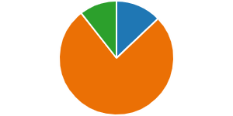

**Did the Child or Any of the Children Attend All or Part of The Meeting?**

Yes (Blue) 78 which is 12%

No (Orange) 492 which is 77%

N/A (Green) 73 which is 11%

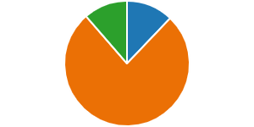

**Reasons for the Child not attending the meeting**

IROs recorded the reasons for children and young people not attending their ICPC or Review Conference and the key reasons are:

* It was not appropriate due to the young age of the child
* The child did not want to attend the meeting
* The meeting was held during school hours and the child preferred to go to school
* The children's views were sought by the Social Worker prior to the meeting

# **8.** **Challenge and Escalation**

8.1 Challenge and escalation are key aspects of the IROs role. Whilst the aim is always to work closely with the social worker and others there are times when it is expected IROs will highlight issues and concerns and escalate these to managers. This is typically where there is drift or delay or a disagreement about a child’s plan.

8.2 There were 18 formal escalations made by IROs during April 2022 and March 2023. This number is fairly low, as it reflects the relational approach of the service, whereby through working closely with social work colleagues, issues are identified and addressed at an early stage, reducing the need for formal escalation. Case records reflect a more complete picture of the input of IROs into monitoring children’s plans and addressing drift and delay.

8.3 Whilst the low number of formal challenges recorded stems from Newcastle’s relational approach the Service did begin to explore the impact of this, and whether the approach taken was beneficial for children and effective at resolving issues. Over the year under review, it was evident that there were several children experiencing delay or experiencing some degree of dissatisfaction with the service provided for them. This highlighted a need for a change in approach, to ensure it is the experiences of children that are foremost in our work. As such, it was decided late in the year under review that there was a need to step up the use of formal challenge where this was in the best interests of the child. It is expected that the use of escalation will increase significantly over the year 2023-24.

8.4 In most cases areas of dispute are clarified at an early stage and resolution is achieved. It is rare for escalations to go above Service Manager level and in almost all cases, disputes are resolved by the sharing of information and clarifying rationale for actions taken. Where there is delay in responding to the Case Discussion and Escalation Process this is escalated to the Service Manager for CSSU who will address it with colleagues in Social Care.

8.5 This might encompass delay in achieving key tasks around a child’s plan or in completing tasks to enable a review meeting to proceed within the child’s timescale. The system requires notified managers to respond within 5 working days and if the matter is not resolved it is escalated to the next person in the line management arrangement. In most cases the IRO will have already made Children’s Social Care aware that the IRO intends to raise a formal escalation as the key aim is to resolve the issue for the child as soon as possible.

8.6 The chart below sets out the reasons that the Case Discussion and Escalation Process (CDEP) was started for the months during April 2022 to March 2023. An analysis of this data shows that drift and delay in the child’s plan is the main reason for the formal

escalation process being implemented during the year by the IRO Service.

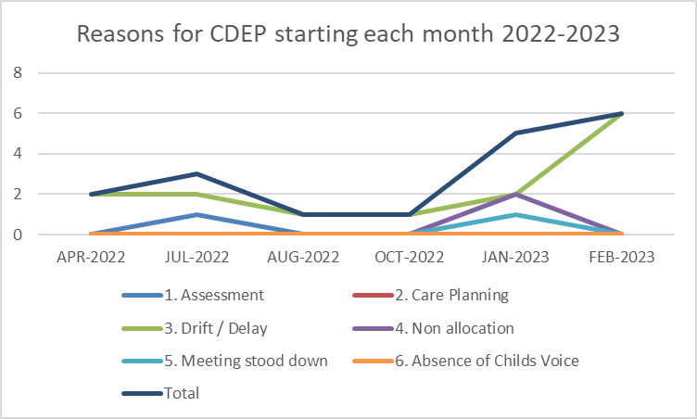

# 8.7 Positively there has been no need to formally escalate any cases with Social Care due to an absence of the voice of the child during the year.

# **9.** **Other areas of CSSU activity**

## Foster Carer Reviews

9.1 The above table shows the number of foster carer reviews completed for each of the last 6 years. All foster carers should receive at least one review per year, and this informs decisions regarding their fitness to continue to foster. Almost all the reviews for 2022/23 were positive with any issues raised with fostering services and addressed. A small

number of issues were identified, such as those identified though the LADO (Local Authority Designated Officer) process.

9.2 Whilst the reviews themselves were largely positive, there were difficulties with aspects of the process. This includes delays in receiving essential information, including views from carers, placing social workers, and supervising social workers. There were also delay by some IROs in the write up of some FCRs. At the time of writing a FCR Improvement Plan is in place, and it is our aspiration that the next annual report will be able to demonstrate improvements in these areas. The Improvement Plan is being led by a Project Group from the IRO Service, Fostering Service with representation from Social Care. Alongside this Plan a new compliance form has been implemented to evaluate the foster carer review process, measure progress, and identify and build on good practice. The Improvement Plan aims to strengthen the whole foster carer review process including:

* Agree performance indicators to measure compliance and the quality of practice in undertaking foster carer reviews
* Agree performance indicators and targets for measuring level and quality of engagement with foster carers in their reviews
* Strengthen quality and provision of information about the experiences of our children in care placed with foster carers from placing social workers
* Strengthen management oversight of Supervising Social Worker’s reports for foster carer reviews

# **10.** **Private Fostering**

10.1 In the year there were two children in approved Private Fostering Arrangements. Both arrangements ended during the period. One child turned 16 in January 2023 and the second returned to his father’s care. There have been a small number of PF enquiries for other children, but none became active Private Fostering Arrangements.

10.2 All arrangements were reviewed by the Private Fostering Lead IRO and the reviews found that all necessary plans and actions were being undertaken. The children were being visited as required under the procedures and the care provide to them remained of a good standard. The children’s voice was captured, and they were able to contribute to the assessment and review process.

10.3 The procedures and practice for children in Private Fostering Arrangements in Newcastle are robust and promote safe care and positive experiences for the children. However, the number of children identified as living in Private Fostering Arrangements in Newcastle continues to be low. Plans are in place to raise awareness, and this includes working with the NUFC Foundation, who are planning on expanding their apprenticeship scheme

to under 16s. Initial information suggests that this could see between 4 and 8 children coming into Newcastle on private fostering arrangements.

10.4 NSCP and CSSU updated its guidance and shared this across the partnership. The Partnership continues to offer training on private fostering. This will continue to be monitored and reviewed in order to build upon the improvement achieved over the last year.

# **11.** **Summary**

11.1 2022/23 has seen:

* Work to roll out and embed relational and restorative practice with a particular emphasis on the IRO service. For example, Child Protection Conferences are now being managed with a greater focus on relationships and working restoratively with families. The meetings start now by focusing on the child and family’s strengths, and the IROs encourage all services to carefully consider what they feel the risks to the child are, as opposed to practitioner worries.
* Stability within the number of children with child protection plans. This has remained at or around 340 children for the past two years which indicates that the right children are being supported and that the change was not short term but a genuine shift in our practice and approach which is bringing positive change to children and families in Newcastle.
* The number of children in care over the period has decreased slightly from 671 on 31st March 2022 to 649 by 31 March 2023 and whilst this is much smaller than the change in child protection figures it does suggest another significant step forward. The data shows that Newcastle is no longer taking in large numbers of children. It has identified the need to strengthen our approach to helping children leave care successfully, via reunification or returning to wider family members or networks.
* A strengthening of our ability to capture and hear the voice of the child along with improved performance management and oversight, that helps us reflect on our work and push for continuous improvement.

# **12. Priorities**

Given progress through 2022 – 2023 and based on a clear understanding of need we will continue to focus on the following four priorities in 2023 – 2024:

* **Priority 1 - Voice of the Child**

Outcome - The work of all IROs will be informed by a full understanding of the child’s lived experience, wishes and feelings. This information will underpin improved outcomes for our children and contribute to the improvement of the service provided by IROs and the CSSU.

* **Priority 2 – People**

Outcome – Children and young people will be safeguarded, and their welfare promoted through a robust, highly skilled, reflective effective IRO workforce with robust admin support working within a learning culture.

* **Priority 3 – Practice and Systems**

Outcome - Safeguarding children procedures and accompanying information reflect up to date processes, internal arrangements, and best practice in order to improve outcomes for our children.

* **Priority 4 – Performance Management, Compliance and Quality Assurance**

Outcome – Assurance is sought, evidenced, and challenged to demonstrate how the IRO service contributes to improved outcomes for our children and young people.

**Appendix 1**

**Snap shot of IRO contact with their children**

The following is key points that the IRO has recorded around their contact with their children. All names have been removed to protect the identity of the child, young person, IRO and carers

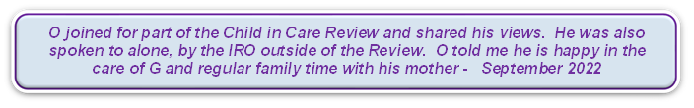

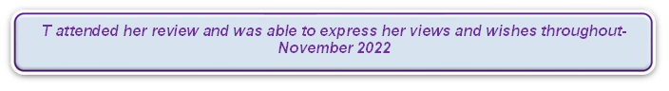

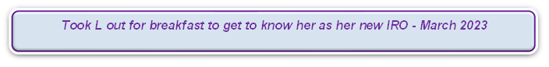

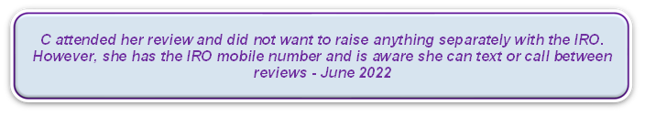

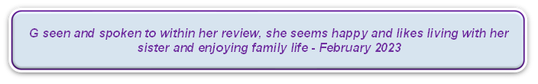

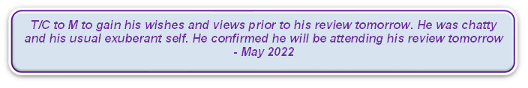

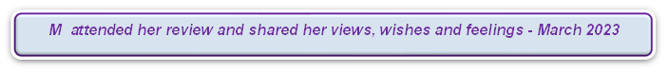

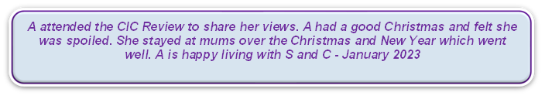

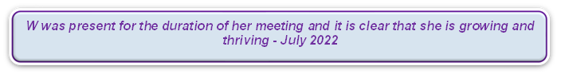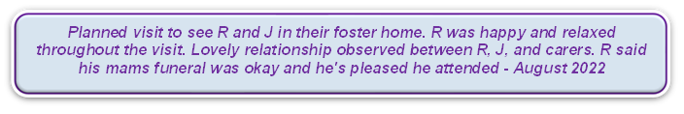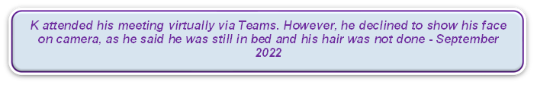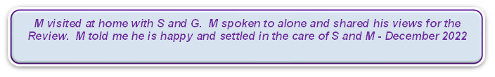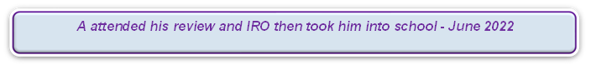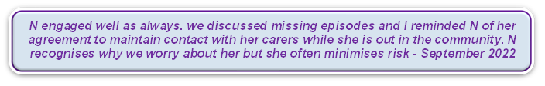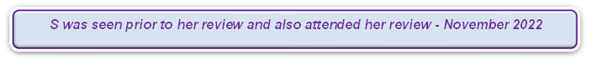

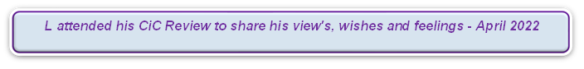



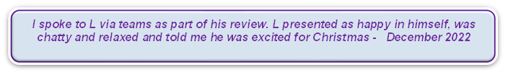

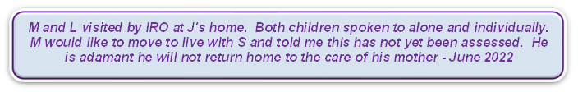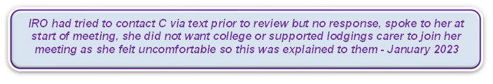

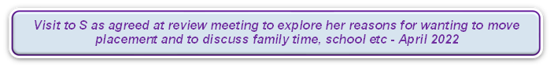

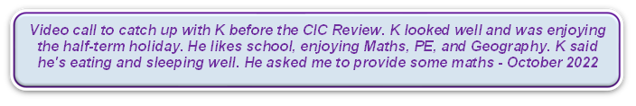

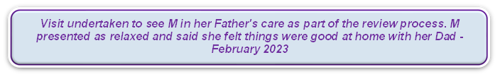

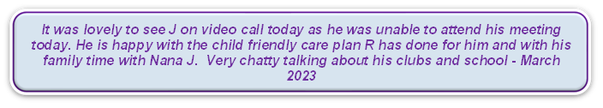

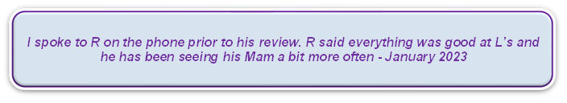

**Appendix 2 – Learning from national and local reviews to improve practice**

**Evaluating and reflecting on the learning from the particularly where there are similarities.**

The following is the cross over learning from the national reviews for Star and Arthur and local reviews that is relevant to the IRO Service and/or where IROs can have an impact on the practice of other professionals to safeguard and protect children:

* Care vs Control functions
* Involves intruding into private lives to understand the quality of parenting, the child’s actual development versus “expected development”
* Extra familial harm vs intra familial harm
* Confidence, capability and able to use expert authority – information sharing, assessment etc
* Making decisions that affect the rest of a child’s life
* Helping families to protect children
* Building trusting relationships – parents and children
* Perception of the child’s experience vs the reality
* Managing ongoing complex risk
* Understanding of diverse and different communities
* Understanding cultural assumptions e.g., ethnicity, sexual orientation etc can affect judgements and decisions

1. [Adoption and Children Act 2002 (legislation.gov.uk)](https://www.legislation.gov.uk/ukpga/2002/38/contents)
2. Inspection of Newcastle local authority children’s services - [50176758 (ofsted.gov.uk)](https://files.ofsted.gov.uk/v1/file/50176758)
3. Child Protection in England National review into the murders of Arthur Labinjo-Hughes and Star Hobson May 2022