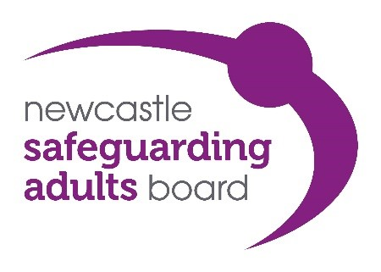

Vision and Priorities

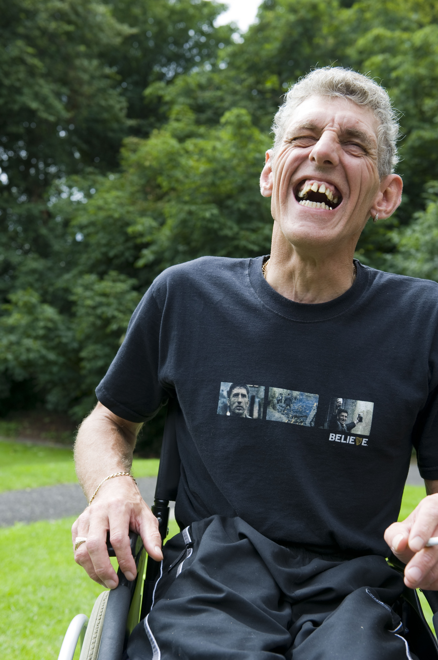

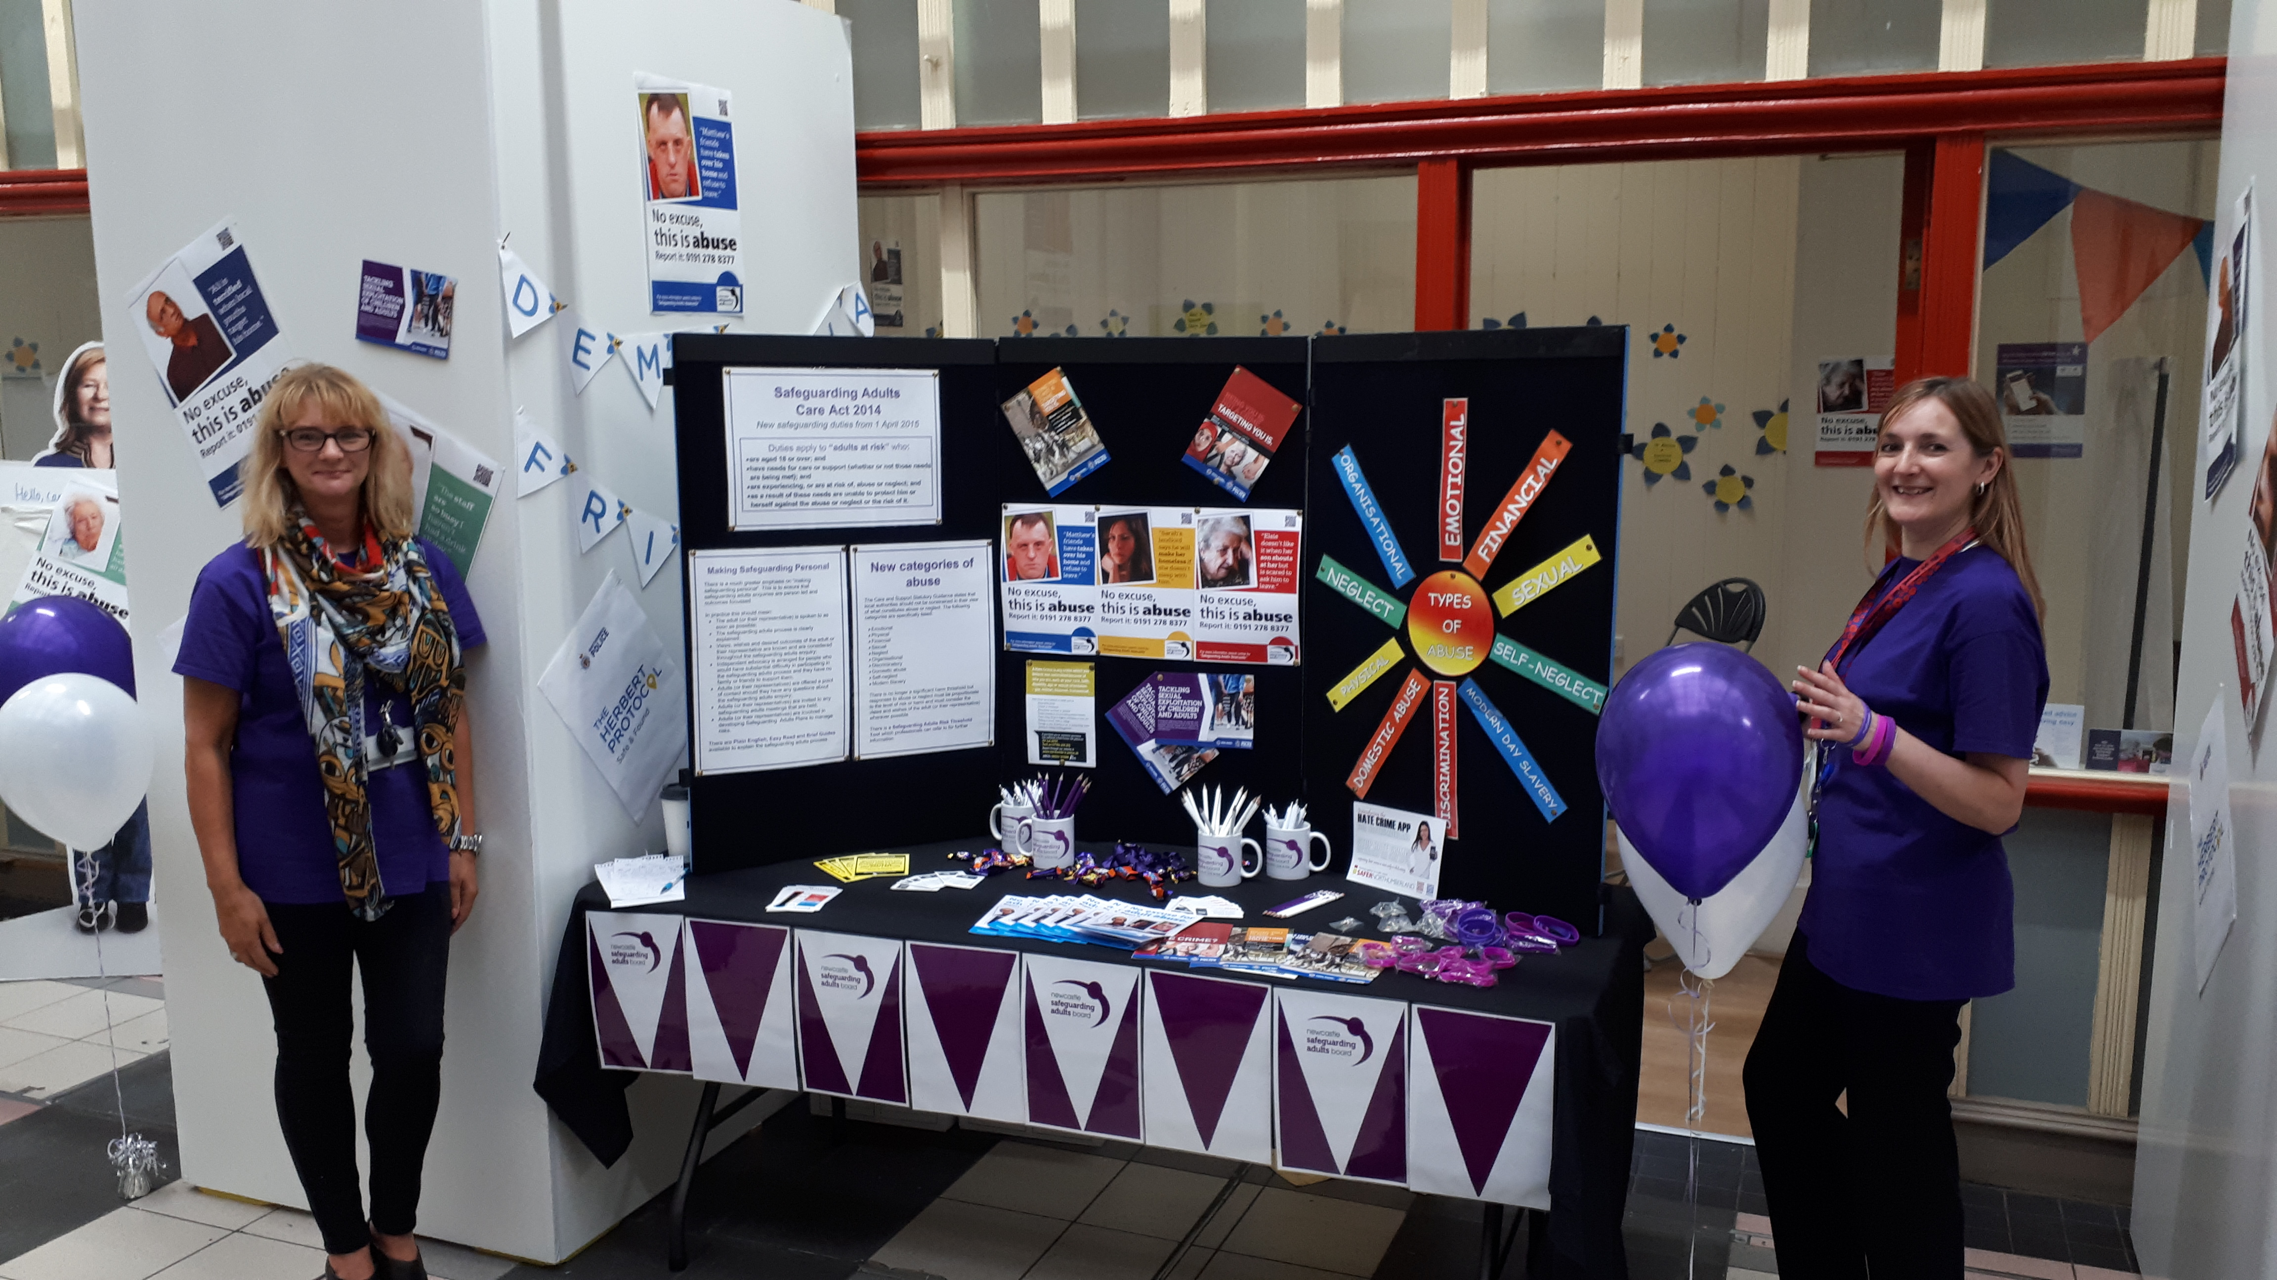

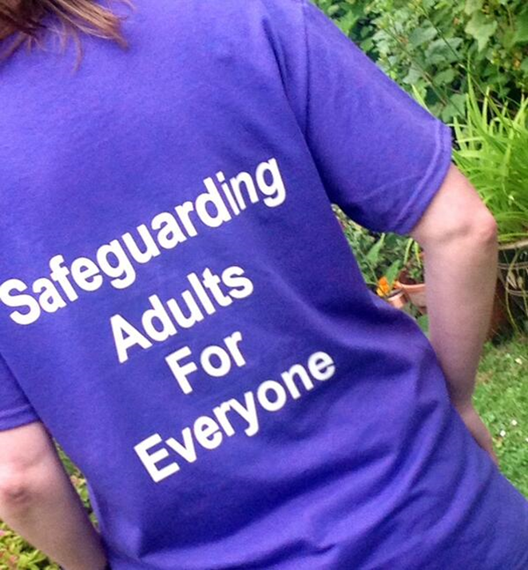

“Our vision is to ensure that Newcastle is an increasingly safer city for adults at risk of abuse and neglect.”

March 2024

- What is Safeguarding?

“Safeguarding means protecting an adult’s right to live in safety, free from abuse and neglect. It is about people and organisations working together to prevent and stop both the risks and experience of abuse or neglect, while at the time making sure that the adult’s wellbeing is promoted including, where appropriate, having regard to their views, wishes, feelings and beliefs in deciding on any action” Care Act (2014).

The Care Act (2014) places statutory requirements on a number of organisations in relation to safeguarding adults.

- What is the Newcastle Safeguarding Adults Board?

Newcastle Safeguarding Adults Board (NSAB) has been established since 23 December 2008. The Board has membership from a wide-range of partners including: the Local Authority, Health Services, Police, Probation, Fire Service, Higher Education, and local community and voluntary sector organisations.

In line with the Care Act, the Newcastle Safeguarding Adults Board’s main objective is to:

  - Assure itself that local safeguarding arrangements and partners act to help and protect adults in its area who:

- have needs for care and support (whether or not the local authority is meeting any of those needs); and
- are experiencing, or at risk of, abuse or neglect; and
- as a result of those care and support needs are unable to protect themselves from either the risk of, or the experience of abuse or neglect.

The core duties of the Newcastle Safeguarding Adults Board are to:
- Publish a strategic annual plan for each financial year that sets out how it will meet its main objective and what members will do to achieve this;
- Publish an annual report detailing what the Board has done during the year to achieve its main objective and implement its strategic annual plan;
- Conduct any Safeguarding Adults Reviews in accordance with Section 44 of the Care Act.

The functions of the Newcastle Safeguarding Adults Board are to:

  - identify the role, responsibility, authority and accountability with regard to the action each agency and professional group should take to ensure the protection of adults;
  - establish ways of analysing and interrogating data on safeguarding notifications that increase the NSAB’s understanding of prevalence of abuse and neglect locally that builds up a picture over time;
  - hold partners to account and gain assurance of the effectiveness of its arrangements;
  - determine and implement arrangements for peer review and self-audit;
  - communicate the need to safeguard adults at risk, raising awareness of how this can be done and encouraging people to do so;
  - develop policies and strategies for protecting adults;
  - develop preventative strategies that aim to reduce instances of abuse and neglect;
  - identify types of circumstances giving grounds for concern and when they should be considered as a referral to the local authority as an enquiry;
  - formulate guidance about the arrangements for managing adult safeguarding, and dealing with complaints, grievances and professional and administrative malpractice in relation to safeguarding adults;
  - develop strategies to deal with the impact of issues of race, ethnicity, religion, gender and gender orientation, sexual orientation, age, disadvantage and disability on abuse and neglect;
  - provide advice on guidance on balancing the requirements of confidentiality with the consideration that, to protect adults, it may be necessary to share information on a ‘need-to-know basis’;
  - identify mechanisms for monitoring and reviewing the implementation and impact of policy and training;
  - carry out Safeguarding Adult Reviews;
  - produce a Strategic Plan and an Annual Report;
  - evidence how SAB members have challenged one another and held other Boards (in the City) to account. For example: Newcastle Safeguarding Children Partnership, Health and Wellbeing Board, Safe Newcastle Board; and
  - promote multi-agency training and consider any specialist training that may be required. Work collaboratively to identify opportunities to jointly commission training with other partnerships, such as the Community Safety Partnership.

The well-established Safeguarding Adults Board gives Newcastle a strong foundation to deliver its vision.

Many partner organisations in Newcastle have dedicated capacity/roles for safeguarding adults and many staff and volunteers have undertaken multi-agency and single-agency safeguarding adults training. This all helps to ensure that people know how to respond appropriately to concerns of abuse and neglect.

The Newcastle Safeguarding Adults Board is subject to external scrutiny on the work it undertakes from the:
- Health & Social Care Scrutiny Committee; and
- Health and Wellbeing Board.

Board members also report through governance systems within their own agencies about the performance of the NSAB.

- Why a local vision?

There continues to be an increasing focus on the profile of safeguarding adults work. It is clear from national developments that partnerships are a critical aspect in sustaining the impetus for improvement and hence the importance of pressing ahead with a local vision for Newcastle.

This document sets out Newcastle Safeguarding Adults Board’s vision. The vision sits alongside a number of other key activities and documents, enabling the Board to strategically review and plan and implement actions

Each provides direction and continuity to the strategic annual plan, ensuring that the achievements of the Board are built upon each year and actions are focussed on the Board’s overall priorities and objectives. The diagram below demonstrates how these all interrelate.

Partner agency priorities
National and emerging issues

Public and practitioner consultation
Cross-partnership priorities

Data and audit information

NSAB Vision– sets out the overall vision of the NSAB and the outcomes it wants to achieve for adults at risk in Newcastle.

NSAB Priorities– establishes the strategic themes that need to be delivered to achieve the Board’s vision; providing the overarching direction to inform subsequent year’s strategic plans.

NSAB Annual Self-Assessment – Each year the NSAB undertakes a self-assessment with partner agencies to understand areas of good practice and areas of improvement.

NSAB Strategic Annual Plan – provides a detailed plan of specific key actions, supporting actions and target timescales required to deliver the Board’s vision and priorities.

NSAB Annual Report – reviews progress in relation to the actions laid out in the strategic annual plan.

Cross-partnership priorities – this refers to priorities of other multi-agency partnerships that are of relevance to the NSAB. This includes, but is not limited to, the NSCP, the Safe Newcastle Board, the Wellbeing for Life Board and the Youth Justice Partnership Board.

Partner agency priorities – individual agencies may have safeguarding adults related priorities which are of such significance that they require NSAB input or oversight.

National and emerging issues – the NSAB will always consider national and emerging issues in the development of its priorities. This will include learning from local and national Safeguarding Adults Reviews (and other relevant review processes).

Data and audit information – The NSAB receives regular reports of safeguarding adults related data and audits.

The Newcastle Safeguarding Adults Board has worked to promote an understanding and taken action to demonstrate that “safeguarding is everybody’s business”. The development of this vision marks the commitment from partners for a shared commitment to keeping adults safe and protected from abuse and neglect.

- Newcastle Safeguarding Adults Board Vision

“Our vision is to ensure that Newcastle is an increasingly safer city for adults at risk of abuse and neglect.”

To achieve this vision the Board will need to work through it’s partnerships and with local communities to:-

- Prevent abuse and neglect from happening;
- Identify and report abuse and neglect;
- Respond to any abuse and neglect that is occurring;
- Support people who have suffered abuse or neglect to recover and to regain trust in those around them; and
- Raise awareness of safeguarding adults and the role everyone can play in responding to, and preventing, abuse and neglect.

- National Drivers for Improvement in Safeguarding Adults

The Newcastle Safeguarding Adults Board priorities reflect the direction set out in current national drivers for change. For this reason the NSAB priorities are designed around the six key principles that underpin all adult safeguarding work (Care Act, 2014), as follows:-

- Empowerment;
- Protection;
- Proportionality;
- Prevention;
- Partnership;
- Accountability.

- Priorities

The Board’s priorities reflect the Board’s vision and provide direction to the further development and improvement of safeguarding practice in Newcastle.

Priority – Empowerment

People are supported and encouraged to make their own decisions and informed consent.

“I am asked what I want as the outcomes from the safeguarding process and this directly inform what happens.”

The Board will continue working towards supporting people to manage risk in their own lives, with professionals supporting their decision making at each stage of Newcastle’s safeguarding adult’s procedures. The Board will work together to further embed the Making Safeguarding Personal approach and ensure that the voice of the person (or their representative) is at the centre of the safeguarding enquiry.

Priority – Protection

Support and representation for those in greatest need.

“I get help and support to report abuse and neglect. I get help so that I am able to take part in the safeguarding process to the extent to which I want.”

The Board will continue to ensure people are aware of what abuse and neglect is and how it can be reported. Where a person is subject to a safeguarding adults enquiry, they will be supported to participate in that.

The Board will ensure that policies, procedures and guidance are in place that provide a framework within which partner organisations can work together effectively to respond to abuse and neglect. These policies, procedures and guidance will reflect emerging developments in national guidance and legislation as well as national, regional and local learning, and new approaches to safeguarding practice.

Priority – Proportionality

The least intrusive response appropriate to the risk presented.

“I am sure that the professionals will work in my interest and they will only get involved as much as is necessary.”

The Board will continue working towards ensuring that safeguarding adults policies, procedures and guidance are used in appropriate circumstances to inform a proportional response to the concerns being raised. Policies, procedures and guidance will be clear and explicit about when a response under safeguarding adults procedures is appropriate and the potential alternatives if these are not appropriate. Professionals will operate within the relevant legal frameworks, including the Mental Capacity Act and the Human Rights Act.

Priority - Prevention

It is better to take action before harm occurs.

“I receive clear and simple information about what abuse is. I know how to recognise the signs, and I know what I can do to seek help.”

The Board will continue working towards gaining assurance from all partner agencies that prevention is a core element in the delivery, commissioning and development of services. This includes providing appropriate information and training to their respective workforces on how to recognise and respond to abuse and neglect and the safe recruitment of those who work with adults at risk.

Priority - Partnership

Services offer local solutions through working closely with their communities. Communities have a part to play in preventing, detecting and reporting neglect and abuse.

“I know that staff treat any personal and sensitive information in confidence, only sharing what is helpful and necessary. I am confident that professionals will work together and with me to get the best result for me.”

The Board will continue to develop joint working practices between and across organisations and other multi-agency partnerships that promote coordinated, timely and effective responses for the individual at risk. The Board aims to foster a “one team” approach that places the welfare of individuals before the “needs” of the system. The Board recognises the role the wider community play in safeguarding adults at risk and will involve the local community when shaping the development of the strategic annual plan.

This will be achieved by ensuring the working relationships between partner agencies are sustained and developed at a strategic and operational level and links to wider networks or Boards are embedded. The Board will consult with community stakeholder groups and promote awareness of safeguarding across the life course.

Priority - Accountability

Accountability and transparency in delivering safeguarding.
“I understand the role of everyone involved in my life and so do they.”

The Board will continue to work to ensure that the roles of all agencies and staff (and their lines of accountability) are clear and explicit. Agencies across the partnership will recognise their responsibilities to each other, act upon them and accept collective responsibility for safeguarding arrangements. The Board will challenge and seek assurance from partner agencies about their safeguarding arrangements. The Board will receive regular management information (data and audits) related to safeguarding adults to help improve performance.

- What Newcastle Safeguarding Adults Board will do next?

- Formulate a strategic annual plan with measurable outcomes;

- Review progress in relation to implementation of the strategic annual plan at each Board meeting;

- The Board plans will continue to be flexible to accommodate any new emerging national guidance;

- Raise awareness of the vision, priorities and strategic annual plan by publishing them and holding relevant awareness events.

- Reference Sources

Specific national and local developments used to reference this document include:-

- Care Act (2014);

- Mental Capacity Act (2005);

- Newcastle Safeguarding Adults Board Annual Reports;

- Newcastle Safeguarding Adults Board Strategic Annual Plans;

- Relevant national and local legislation, policy, procedures, strategies and reports in relation to children (e.g. Working Together (2023))

