Newcastle Safeguarding Adults Board

**Easy Read Guide**

**Safeguarding Adults**







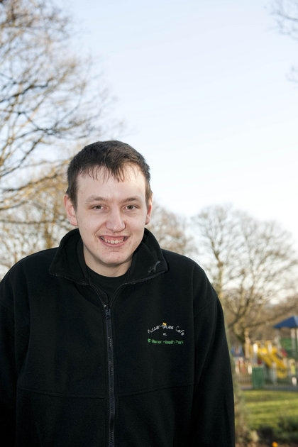

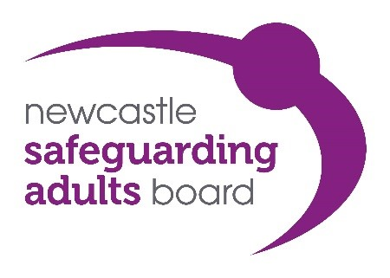

**Introduction**

|  |  |
| --- | --- |
| **What is this guide about?** | |
| Ameem-2 | This guide has been written by the Newcastle Safeguarding Adults Board to help you to understand what safeguarding adults means. |
| Board | The Board is made up of lots of different people like social workers, police officers, doctors and nurses**.** |
| Defendent-court-guarded | It is our job to protect people in Newcastle from abuse. |
| Winterbourne-abuse-11 | When abuse has happened we work together to stop the abuse happening. |
| Home_Inspection-7 | Some people will be able to read the guide on their own. Other people will need help to read and understand it. |

This guide was produced by the Newcastle Safeguarding Adults Unit.

A lot of people and groups helped us to make this guide.

We would like to thank everyone that helped us.

Thank you

**Contents**

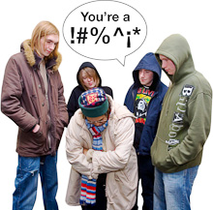Chapter 1

**Page 5** What does safeguarding adults mean?

**Page 5** What is abuse?

**Page 6** Tell someone

**Page 8** What is a safeguarding adults referral?

**Page 10** What happens when someone tells Adult Social Care abuse is happening?

Chapter 2

**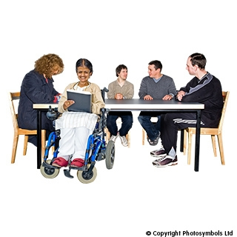Page 11** What happens after a safeguarding adults referral?

**Page 13** Information for you

**Page 14** What happens at safeguarding adults meetings?

**Page 16** Privacy

**Page 17** The end of the safeguarding adults enquiry

**Page 18** What to do if you are not happy with what has happened?

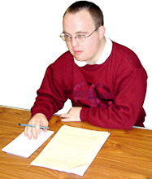Chapter 3

**Page 19** Point of contact for you

**Page 19** Information about your meeting

**Page 20** Useful telephone numbers

**What does safeguarding adults mean?**

|  |  |
| --- | --- |
| Kick-2 | Safeguarding adults means working together to stop abuse happening and help everyone to live free, happy lives and make their own choices. |
| **What is abuse?** | |
| Gang_bullies1  Sexual_HarassmentCoins_hand1Fighting | Abuse is when someone does or says things to you that make you upset or frightened. Abuse can happen in different ways.  It could be:   * Emotional * Financial * Sexual * Physical * Neglect * Discriminatory |

**Tell someone**

|  |  |
| --- | --- |
|  | If you think that you or somebody that you know is being abused you should tell someone. |
| MP900448458[1]Tell_police5Ward_Sister | **You can tell someone you trust.**  This could be:   * A nurse * The police * A social worker * A family member * A friend * A carer |
| Police_notes | **In an emergency ring 999** |
|  | Once you have told someone you trust they should tell  Adult Social Care.  This is called making a  **safeguarding adults referral.** |

**What is a safeguarding adults referral?**

|  |  |
| --- | --- |
| Gang_bullies1 | A **safeguarding adults referral** is when somebody tells Adult Social Care that abuse is happening. |
| Social_Work-2 Anybody can make a **safeguarding adults referral.**  **Computer with www words on screen**  [Online referral form](https://mycarenewcastle.org.uk/form/SAIE?latest=true#!/) | |
| **\\dfsccs001v\dfsroot\homedrive$\44380\My Documents\My Pictures\clock 2.jpg** | Monday – Friday  8am-5pm    **0191 278 8377** |
|  | Weekends and evenings, 5pm-8am  **0191 278 7878** |
| [ANd9GcRimmlUgWanbouaB90LZ8OW12S93ZBTVRyy5DgHRBLYoEJ1c_w6U4uJDw](http://www.google.co.uk/imgres?imgurl=http://www.rnid.org.uk/VirtualContent/83652/T323_MC6000_Textphone___1.jpg&imgrefurl=http://www.rnid.org.uk/shop/products/textphones/mc6000.htm?showImage%3Dtrue&usg=__3k95z3JHp76CbGVm61oKfEyBEPM=&h=328&w=410&sz=62&hl=en&start=3&zoom=1&um=1&itbs=1&tbnid=D8ds9Ad4KFdNHM:&tbnh=100&tbnw=125&prev=/images?q%3Dtextphone%26um%3D1%26hl%3Den%26safe%3Dactive%26sa%3DN%26rls%3Dcom.microsoft:*%26tbs%3Disch:1&ei=mKl4Tb6AIIPUtAayy-zvBg) | **Textphone** 0191 278 8359  (Monday - Friday, 8am-5pm) |
| http://www.gomonews.com/wp-content/uploads/2009/08/istock_sms.jpg | **SMS** 07968474891  (SMS for D/deaf or hard of hearing customers)  (Monday - Friday, 8am-5pm) |
| Hand writing address on envelope | **Sending a letter to:**  Community Health and Social Care Direct  Westgate Community Complex  West Road  Newcastle upon Tyne  NE4 9LU |
| Computer with www words on screen | **Email:**  scd@newcastle.gov.uk |

**What happens when someone tells Adult Social Care abuse is happening?**

|  |  |
| --- | --- |
| Home_Inspection-7 | When Adult Social Care get a **safeguarding adults referral** they need to find out how serious the abuse is. |
| **To help decide what should happen, Adult Social Care will:** | |
| Social_Work-2 | Talk to you about what has happened and offer you support. |
| Meeting_table1 | Talk to other people to find out what has happened. |
| Tell_police5 | Take action to make sure that you are safe. |

**What happens after a safeguarding adults referral?**

|  |  |
| --- | --- |
| This section explains what happens after a **safeguarding adults referral** has been made. | |
| NCC Logo Black | Adult Social Care must start a **safeguarding adults enquiry.** |
| Meeting_table1 | This means finding out more about the abuse or neglect and how to keep you safe. |
| There are different stages in a **safeguarding adults enquiry.** | |
| http://addfx.co.uk/photogallery/photo5664/PHOTO/EXIT0009.jpg | Safeguarding could end at any of the stages. A decision will be made with you about whether the **safeguarding adults enquiry** should end. |
| **Remember:** As soon as people know you may be unsafe, action will be taken. | |
| **Social_Work-2Stage 1** | A safeguarding adults referral is made to Adult Social Care. |
| Home_Inspection-7**Stage 2** | Adult Social Care gather further information about the abuse or neglect. |
| Plan**Stage 3** | A plan is made to investigate the concerns of abuse or neglect. A person or agency completes the investigation. |
| Meeting_notice**Stage 4** | The plan to keep you safe is talked about at a meeting. A decision will be made about whether there needs to be another meeting to check the plan is working. |

**Information for you**

|  |  |
| --- | --- |
| **Interview_questions** | If you are the adult who has been abused, professionals need to know your views. If you want someone else to speak for you or go to the meetings for you, that is ok. |
| **Homophopia** | If you would find it very difficult to be involved, Adult Social Care have to find out if there is someone who could support you or represent you. This could be a family member, friend or advocate. |
| **Transport** | You will be invited to as many meetings as possible and you will get help to get to the meetings. |

**What happens at safeguarding adults meetings?**

|  |  |
| --- | --- |
| Meeting_notice | Every safeguarding adults meeting has a **chairperson.**  They run the meeting and make sure you understand what is being talked about. |
| **Home_Inspection-7** | You can talk to the chairperson before or after the meeting.  They will explain what is going to happen at the meeting. They will answer any questions you might have. |
| [http://t2.gstatic.com/images?q=tbn:ANd9GcT6DSzVsSN-1e1V_gZlIF48kRKL9wQf0JrPiwXfGvGP2TbSqSxO61Ddwjvzzg](http://www.google.co.uk/imgres?imgurl=http://www.anderson-online.co.uk/lions2009/agenda.jpg&imgrefurl=http://www.anderson-online.co.uk/lions2009/Activities.htm&usg=__gboIZ91WjHD5dFgB_o3CXjgMVD4=&h=806&w=750&sz=112&hl=en&start=2&zoom=1&um=1&itbs=1&tbnid=LYWiexquvCkoeM:&tbnh=143&tbnw=133&prev=/images?q%3Dagenda%26um%3D1%26hl%3Den%26safe%3Dactive%26sa%3DN%26ndsp%3D20%26tbs%3Disch:1&ei=2aCATcCQKca2hAf7xNCUBw) | There will be an agenda. This is a plan of what will be talked about at the meeting. |
| **Think7** | Everyone at the meeting will listen to you.   * You can talk about what happened to you. * You can say how you feel about it now. * You can say what you want to happen next. |
| **Think_twice2** | You can ask if you do not understand what is being said. |
| http://essay-writing-service.co.uk/data/79.en/73/youthink1.jpg | There will be someone taking notes at the meeting. |
| http://www.cramondpsa.org.uk/wp-content/uploads/2011/03/Minutes.bmp | These are sometimes called **minutes.** Notes are made so people remember what was talked about. |
| You will be sent a copy of the **minutes** and the **safeguarding adults plan** if you want them. | |

**Privacy**

|  |  |
| --- | --- |
|  | Sometimes it might not be possible to invite you to a meeting. This might be because other people will be talked about and it is not possible to share their private information with you. |
| **Meeting_notice** | The other people would not be invited to the meeting either and would not be told anything about you.  It is important that information about you is kept private. |
| **If you are not invited:** | |
| **Social_Work-4** | You will be told about what is being done to protect you. |
| **Think_twice2** | You will be asked if there is anything else that you think needs to be done. |

**The end of the safeguarding adults enquiry**

|  |  |
| --- | --- |
| http://addfx.co.uk/photogallery/photo5664/PHOTO/EXIT0009.jpg | The **safeguarding adults enquiry** will only end when professionals are sure that everything has been done to keep you safe. |
| Think_twice2 | You can say if you think anything else needs to be done. |
|  | Everyone that has been involved will be told what has been done and why it is safe to end the **safeguarding adults enquiry**. |

**What to do if you are not happy with what has happened**

|  |  |
| --- | --- |
| MC900433161[1] | If you are unhappy about the process you can tell Adult Social Care why you are unhappy by contacting the people below. |
| Hand writing address on envelope | Complaints and Customer Relations Team  Floor 4  Civic Centre  Newcastle upon Tyne  NE1 8QH |
|  | **Telephone:**  0191 277 7427  (Monday-Friday, 9am-5pm) |
| **Computer with www words on screen** | **Email:**  [ComplaintsAdults@newcastle.gov.uk](mailto:ComplaintsAdults@newcastle.gov.uk) |

**Information for you**

**Insert/draw picture below**

Your point of contact is:

**…………………………………………………………….**

You can contact them if you have any questions about safeguarding adults.

You can contact them:

**[](http://www.google.co.uk/imgres?imgurl=http://www.mobilephonereviews.org/uploads/Image/Samsung%20G800%205MP%20Camera%20Mobile%20Phone.jpg&imgrefurl=http://www.mobilephonereviews.org/samsung/samsung-g800-5mp-camera-mobile-phone/&usg=__tPU3CW6gQs4ruzJuRK5F46vOJ9g=&h=657&w=338&sz=27&hl=en&start=6&zoom=1&itbs=1&tbnid=ILhoeBke2G6IsM:&tbnh=138&tbnw=71&prev=/images?q%3Dmobile%2Bphone%26hl%3Den%26safe%3Dactive%26gbv%3D2%26tbs%3Disch:1&ei=mAl2TcLjJNGHhQeY8JWZBg)……………………………………………………………….**

[](http://www.google.co.uk/imgres?imgurl=http://www.wheretoinvestmoney.co.uk/Images/computer.jpg&imgrefurl=http://www.wheretoinvestmoney.co.uk/where-to-invest-money-computers.html&usg=__40By3gC8dQ3Q8kIGS1ynjLuUONc=&h=1024&w=965&sz=63&hl=en&start=5&zoom=1&itbs=1&tbnid=MhCDI1g3E7P7tM:&tbnh=150&tbnw=141&prev=/images?q%3Dcomputer%26hl%3Den%26safe%3Dactive%26gbv%3D2%26tbs%3Disch:1&ei=xQl2Te2SDM6ChQfb-5CZBg)**…………………………………………............................**

You can contact them at these times:

|  |  |  |  |  |  |  |
| --- | --- | --- | --- | --- | --- | --- |
| **Mon** | **Tues** | **Weds** | **Thurs** | **Fri** | **Sat** | **Sun** |
|  |  |  |  |  |  |  |

[](http://www.google.co.uk/imgres?imgurl=http://www.achievemaster.com/wp-content/uploads/2009/10/clock_with_no_hands.jpg&imgrefurl=http://www.achievemaster.com/tag/marketing/&usg=__aMCg4D3bQtqFwLwMHeIhzVmm3ew=&h=194&w=230&sz=9&hl=en&start=1&zoom=1&itbs=1&tbnid=qqjq1Q4EwoON-M:&tbnh=91&tbnw=108&prev=/images?q%3Dclock%2Bno%2Bhands%26hl%3Den%26safe%3Dactive%26gbv%3D2%26tbs%3Disch:1&ei=OQp2TdOSFYnChAeP17SZBg)

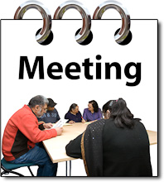

Your safeguarding adults meeting will be held:

|  |  |
| --- | --- |
| **Date MCj04348040000[1]** |  |
| **Time** [http://t2.gstatic.com/images?q=tbn:ANd9GcSibhRzXxIPC1qmSZ8O-f9iWn98yoizLwfGUBIBYkKvDSsYZqbbc_2lzKY](http://www.google.co.uk/imgres?imgurl=http://www.achievemaster.com/wp-content/uploads/2009/10/clock_with_no_hands.jpg&imgrefurl=http://www.achievemaster.com/tag/marketing/&usg=__aMCg4D3bQtqFwLwMHeIhzVmm3ew=&h=194&w=230&sz=9&hl=en&start=1&zoom=1&itbs=1&tbnid=qqjq1Q4EwoON-M:&tbnh=91&tbnw=108&prev=/images?q%3Dclock%2Bno%2Bhands%26hl%3Den%26safe%3Dactive%26gbv%3D2%26tbs%3Disch:1&ei=OQp2TdOSFYnChAeP17SZBg) |  |
| **Where** |  |

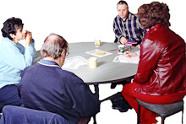The other people at the meeting will be:

…………………………………………………………

……………………………………………...................

………………………………………………………….

………………………………………………………….

There might be more safeguarding adults meetings. You can write them down here:

|  |  |
| --- | --- |
| **Date MCj04348040000[1]** |  |
| **Time** [http://t2.gstatic.com/images?q=tbn:ANd9GcSibhRzXxIPC1qmSZ8O-f9iWn98yoizLwfGUBIBYkKvDSsYZqbbc_2lzKY](http://www.google.co.uk/imgres?imgurl=http://www.achievemaster.com/wp-content/uploads/2009/10/clock_with_no_hands.jpg&imgrefurl=http://www.achievemaster.com/tag/marketing/&usg=__aMCg4D3bQtqFwLwMHeIhzVmm3ew=&h=194&w=230&sz=9&hl=en&start=1&zoom=1&itbs=1&tbnid=qqjq1Q4EwoON-M:&tbnh=91&tbnw=108&prev=/images?q%3Dclock%2Bno%2Bhands%26hl%3Den%26safe%3Dactive%26gbv%3D2%26tbs%3Disch:1&ei=OQp2TdOSFYnChAeP17SZBg) |  |
| **Where** |  |

**If you are worried about that someone is at risk of abuse or neglect, get in touch!**

|  |  |
| --- | --- |
| Ask_directions1 | For adults  Newcastle City Council on 0191 278 8377  Or make an [online safeguarding adults referral](https://mycarenewcastle.org.uk/form/SAIE?latest=true#!/) |
| Delilah-9 | For children  Newcastle City Council on 0191 277 2500 |
| 999-emergency | In an emergency always dial 999 |
| Google-search | You can find out more about keeping people safe from abuse and neglect on our website  [www.newcastlesafeguarding.org.uk](http://www.newcastlesafeguarding.org.uk) |

