A Toolkit for working with young refugees and asylum seekers

Contents

1. Asylum Process 1

3. Asylum Support 4

4. Age Assessments 4

5. Health 5

6. Education 6

7. Local Authority Support 8

8. Journeys to the UK 9

9. Mental health and wellbeing 10

10. Child Trafficking 12

ECPAT Child Trafficking in the UK 2021 12

**DisasterReady.Org** Supporting Children Who Have Gone Through Difficult Experiences 13

**Each of the above headings is a hyperlink to the relevant section. Select Ctrl on your keyboard and then click on the heading and it will take you directly to that subject.**

**Within each section the heading for the document, resource or tool is also a hyperlink to the relevant website.**

## Asylum Process

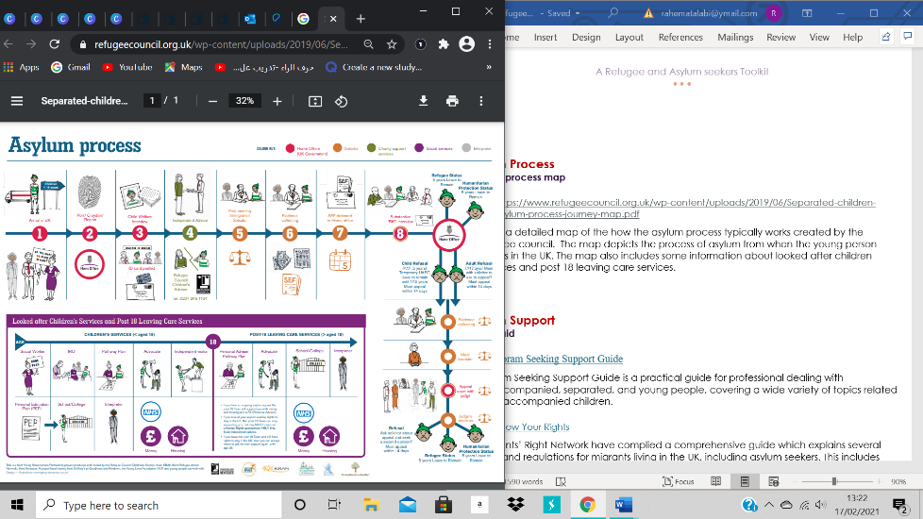

[**[Asylum Process Map]( https://www.refugeecouncil.org.uk/resources/separated-children-asylum-process-journey-map/  )**](https://www.refugeecouncil.org.uk/resources/separated-children-asylum-process-journey-map/)

The asylum process map is a colour coded visual resource to assist newly arrived separated children and care leavers who have made a claim for asylum in the UK to understanding the asylum process and their rights & responsibilities as looked after children and care leavers in England. It was produced by Refugee Council and partners in Kent. You can request for hard copies to be posted to you.

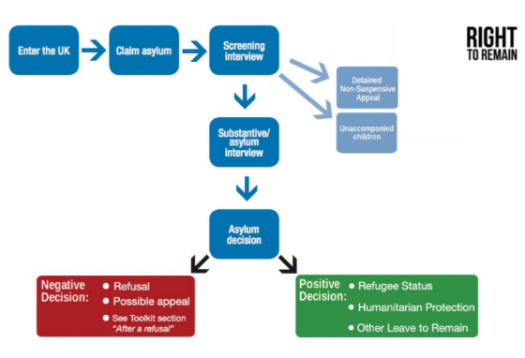[**Right to Remain Toolkit**](https://righttoremain.org.uk/toolkit/claimasylum/)

This toolkit is a comprehensive guide to the UK immigration and asylum system, by giving an overview of the legal system, rights, and actions to take to support an individual. The toolkit is available in a range of languages. It Includes flow charts of the asylum process at different stages including appeals, Judicial Reviews and fresh claims.

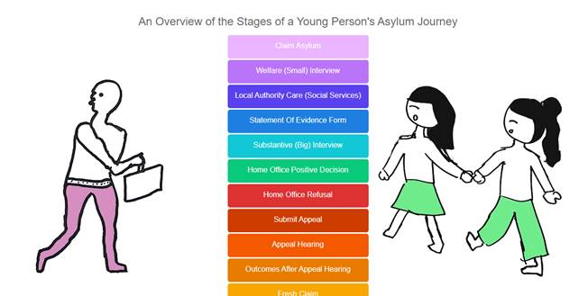[**Young Asylum Guide**](https://youngasylumguide.org.uk/)

This is an interactive guide explaining the different stages of the asylum process for children with examples and “problems solved” on each step.

[**Legal Aid & Immigration Advice**](https://www.youtube.com/watch?v=UyTOMYjpuHs)

Know your Rights: a short film made by young people in London from a youth group called Brighter futures about immigration advice and what a good and bad solicitor looks like.

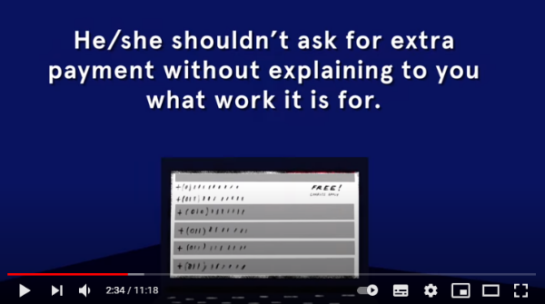

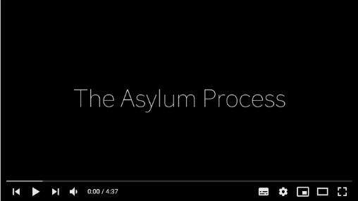

[**Asylum process film**](https://www.youtube.com/watch?v=nVxQufliVLU&list=PL_ea5GGKK3gA3NYmKuMHTLSj1soEhbE0a&index=6)

‘We are tired. We are tired of waiting, tired of not understanding, tired of feeling alone. Nothing is certain, we can’t plan our futures.” A short film made by young people in Birmingham as part of the Surviving to Thriving Project about their experiences of the asylum process.

[**Waiting for Refugee Status**](https://www.youtube.com/watch?v=kLXCaAfQtaI&list=PL_ea5GGKK3gA3NYmKuMHTLSj1soEhbE0a&index=12)

‘I wish had had somebody to talk to and tell me what is happening’ A short film made by young people in Cambridge as part of the Surviving to Thriving Project. They talk about their experience of waiting for their refugee status and the impact this made on the.

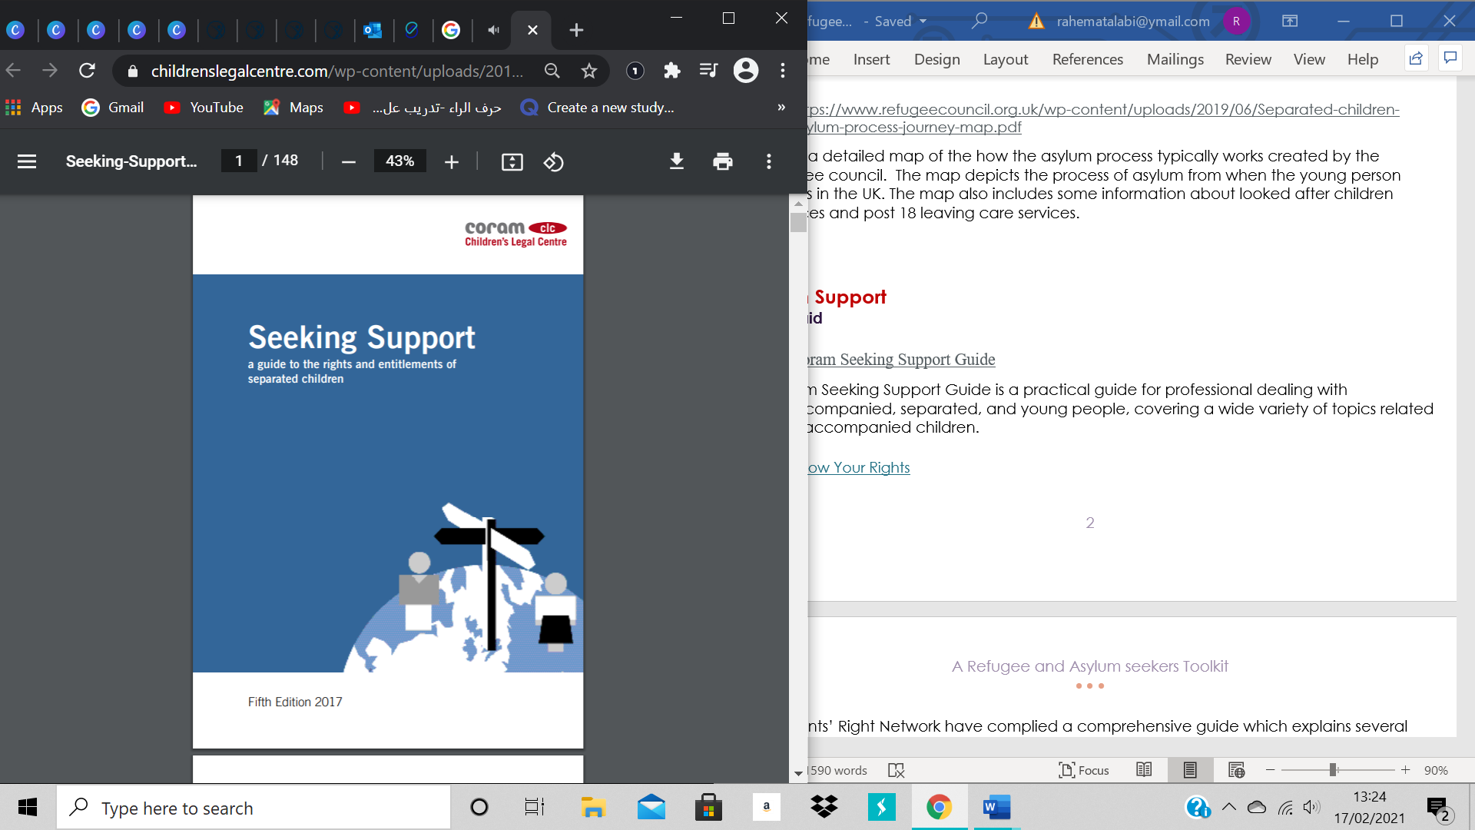

[**Coram Seeking Support Guide**](https://www.childrenslegalcentre.com/wp-content/uploads/2017/05/Seeking-Support-2017.pdf)

Coram Seeking Support Guide is a practical guide for professional dealing with unaccompanied, separated, and young people, covering a wide variety of topics related to unaccompanied children.

Also several separated factsheets on [the asylum process](https://www.childrenslegalcentre.com/?sfid=132&_sft_resource_topic=asylum) and associated rights such as Family Reunion and UASC leave.

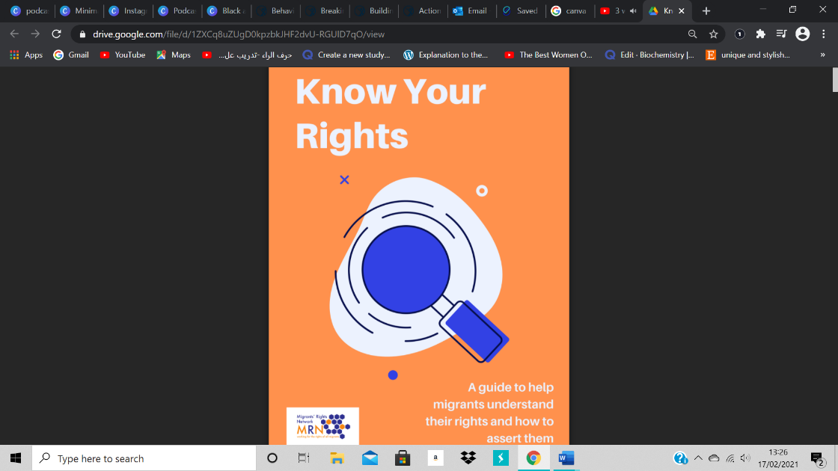

[**Know Your Rights**](https://drive.google.com/file/d/1ZXCq8uZUgD0kpzbkJHF2dvU-RGUlD7qO/view)

Migrants’ Right Network have complied a comprehensive guide which explains several laws and regulations for migrants living in the UK, including asylum seekers and those without status. It includes:

Banking, Driving, Employment, Health, Education, Housing, Social services, detention and deportation

1. [**National Transfer Scheme Protocol**](https://assets.publishing.service.gov.uk/government/uploads/system/uploads/attachment_data/file/1041861/NTS_Protocol_14_Dec_2021_Final_version.pdf)

The National Transfer Scheme first began operating in 2016 and formed the basis of an agreement between local authorities to ensure a fairer, more equitable distribution of unaccompanied children across local authorities. The protocol was updated in Dece,ber 2021, following the scheme becoming mandatory.

## Asylum Support

[**Right to Remain Toolkit**](https://righttoremain.org.uk/toolkit/asylum-support/) – includes a section explaining about asylum support, S4, S95 & S98, initial accommodation, providing destitution and asylum support appeals. This would only be relevant for individuals who are treated as adults within the asylum system and not eligible for care leaving support.

## Age Assessments

[**ADCS Age Assessment Guidance**](https://adcs.org.uk/assets/documentation/Age_Assessment_Guidance_2015_Final.pdf) to assist social workers and their managers in undertaking age assessments in England.

[**Wales Age Assessment Toolkit for UASC**](https://gov.wales/sites/default/files/publications/2021-06/unaccompanied-asylum-seeking-children-age-assessment-toolkit.pdf) [Welsh Government Briefing: supporting unaccompanied asylum-seeking children](https://gov.wales/sites/default/files/pdf-versions/2021/2/1/1612801487/briefing-supporting-unaccompanied-asylum-seeking-children-wales.pdf)

Scotland Age Assessment Guidance - [Age Assessment Practice Guidance for Scotland (migrationscotland.org.uk)](http://www.migrationscotland.org.uk/uploads/documents/Age%20Assessment%20Guidance%202018.pdf)

[**Home Office Assessing Age Guidance**](https://assets.publishing.service.gov.uk/government/uploads/system/uploads/attachment_data/file/1045849/Assessing_age.pdf)

**National Age Assessment Board – NAAB**

Through the [Nationality and Borders Act 2022](https://www.gov.uk/government/news/home-office-to-introduce-scientific-methods-for-assessing-the-age-of-asylum-seekers) the Home Office will introduce scientific methods for assessing asylum seekers and the legislation will create the NAAB, appointed by the Home Secretary to oversee the system. Review local authority assessments and carry out its own in some situation. The NAAB guidance is being consulted on and is due to be launched in June 2022.

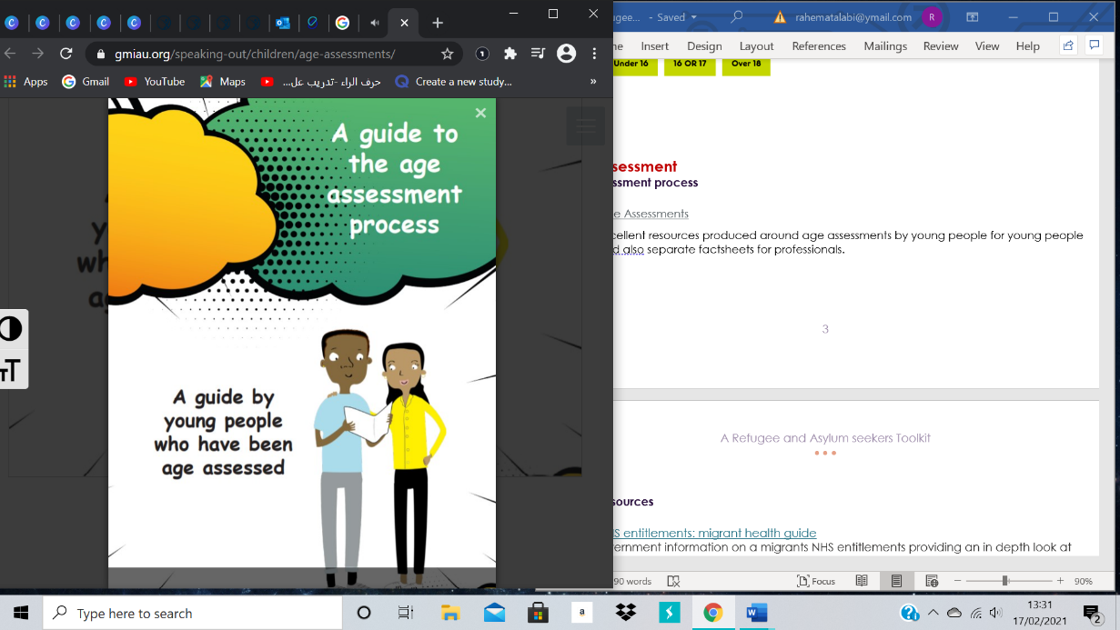

[**Age Assessment Guides and Factsheets**](https://gmiau.org/speaking-out/children/age-assessments/)

Resources produced by the Greater Manchester Immigration Aid Unit around age assessments by young people for young people and also separate factsheets for key professionals supporting young people.

## 

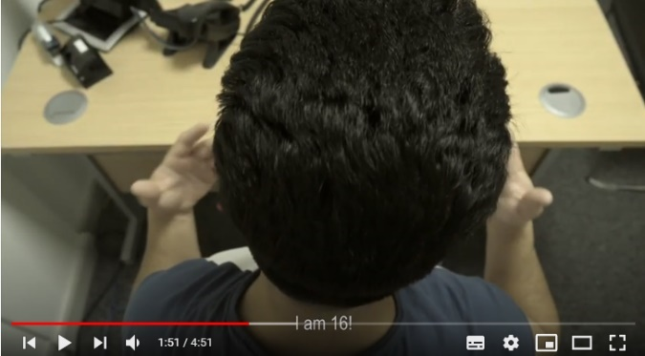[**Age assessment video**](https://www.youtube.com/watch?v=u4QXSYBNWNs&list=PL_ea5GGKK3gA3NYmKuMHTLSj1soEhbE0a&index=8)

‘Leaving my foster family felt like leaving my own family all over again.’ Young people in Birmingham created a short video about age assessments as part of the Surviving to Thriving Project.

## Health

[NHS entitlements: migrant health guide](https://www.gov.uk/guidance/nhs-entitlements-migrant-health-guide?utm_medium=email&utm_campaign=govuk-notifications&utm_source=392ef4d0-a3f0-4124-848e-31487ee570bc&utm_content=daily)

This is government information on a migrants’ NHS entitlements providing an in depth look at the services in the NHS. This provides migrants an overview of the NHS and how the healthcare system generally works. Also, information on Brexit and COVID -19 and there relation with the NHS.

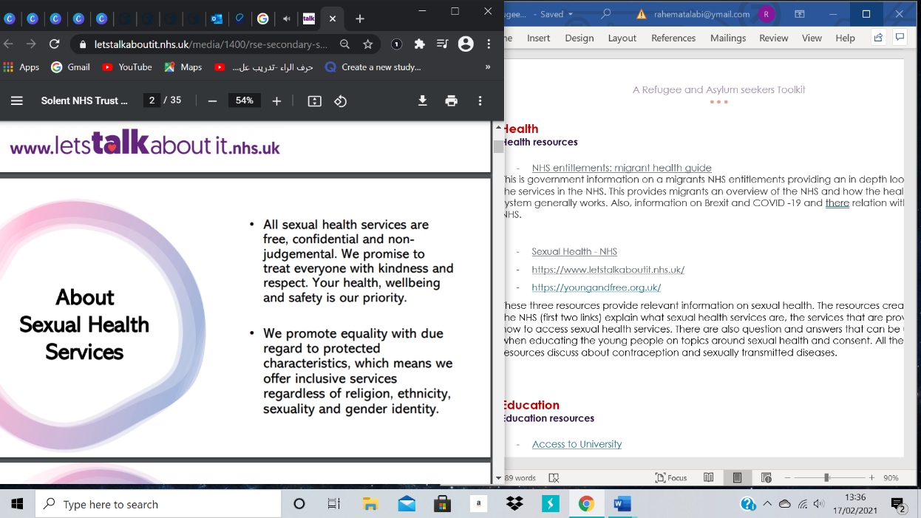[**Sexual Health - NHS**](https://www.letstalkaboutit.nhs.uk/media/1400/rse-secondary-school-presentation-sexual-health-services.pdf)

[**Let’s Talk About It**](https://www.letstalkaboutit.nhs.uk/)

[**Young and Free**](https://youngandfree.org.uk/)

These three resources provide relevant information on sexual health. The resources created by the NHS (first two links) explain what sexual health services are, the services that are provided, how to access sexual health services. There are also question and answers that can be used when educating young people on topics around sexual health and consent. All the resources discuss contraception and sexually transmitted diseases.

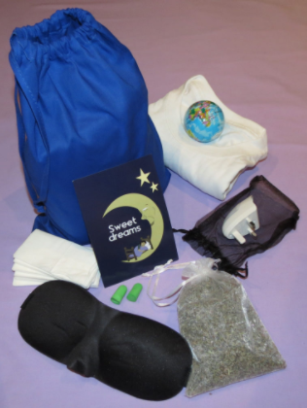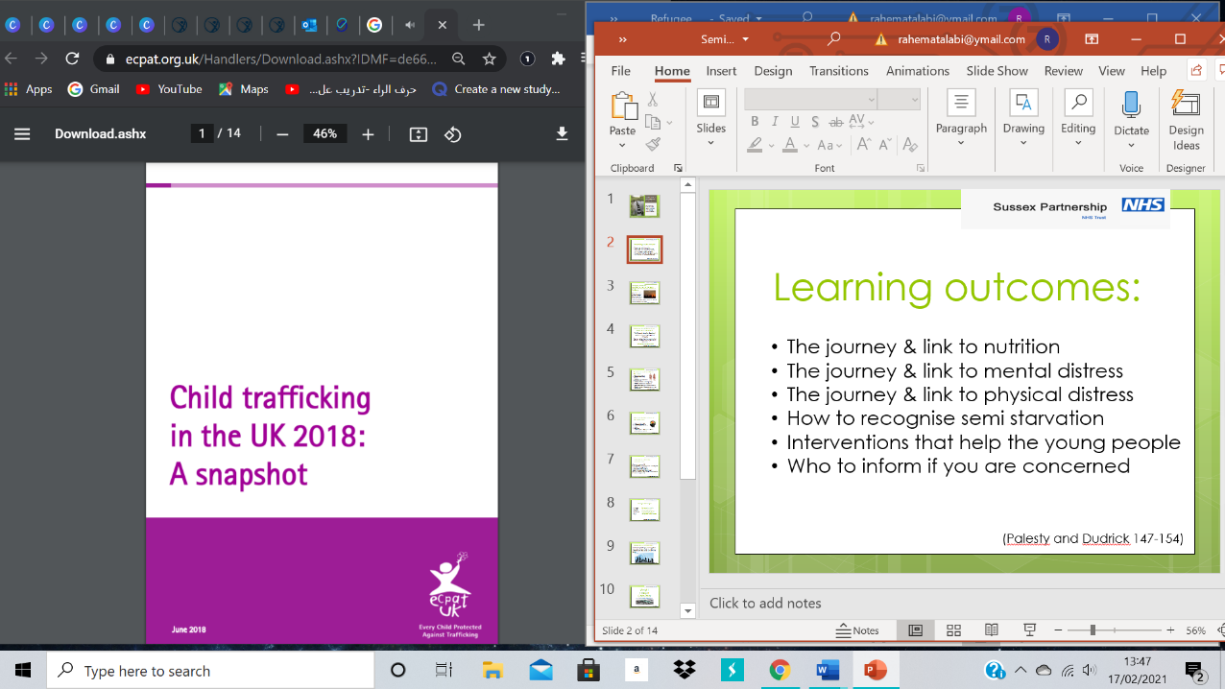[**Sleep and the things that make a difference**](https://www.uaschealth.org/resources/mental-health/sleep-eat-hope/)

UASC Health Webpage which includes a video made by separated children about what makes a different to their sleep. Other resources on the site include:

* Semi-starvation on journey to the UK
* Screening for psychological distress
* Sleep packs and disordered sleep patterns
* Graphical user interface, website

  Description automatically generated

[**Separated Child Foundation Sleep & Arrival Packs**](https://separatedchild.org/our-work/sleep-packs/)

A Sleep Pack is a pouch that contains: a night shirt, a plug-in night light, a lavender bag, a specially created ‘Sweet Dreams’ card, an eye mask, ear plugs, tissues and a stress ball. The Foundation provides these packs and arrival packs with basic essentials for free, you just need to cover postage.

[**Royal College of Paediatrics & Child Health**](https://www.rcpch.ac.uk/resources/refugee-unaccompanied-asylum-seeking-children-young-people-guidance-paediatricians) Information to support paediatricans in the assessment and management of children and young people of refugee background with links to key external information and resources.

[**Migrant health - Royal College of Nursing**](https://www.rcn.org.uk/clinical-topics/public-health/inclusion-health-care/migrant-health) Resources for primary healthcare professionals to help them support migrant patients. Includes guidance on health topics, entitlements to an interpreter, information on data sharing and migrants’ entitlements to NHS services.

[**CoramBAAF**](https://corambaaf.org.uk/search-results?keywords=unaccompanied+asylum&content-type=All) **–** range of resources for fostering and caring for unaccompanied children

[**Pediatrics – UASC Health**](https://www.uaschealth.org/resources/paediatrics/)Range of resources developed by paediatricians and designated professionals in Kent to support assessing and addressing the health needs of unaccompanied children.

[**Doctors of the World**](https://www.doctorsoftheworld.org.uk/useful-resources) – Range of tools for healthcare professionals including migrants’ rights to healthcare.

## Education

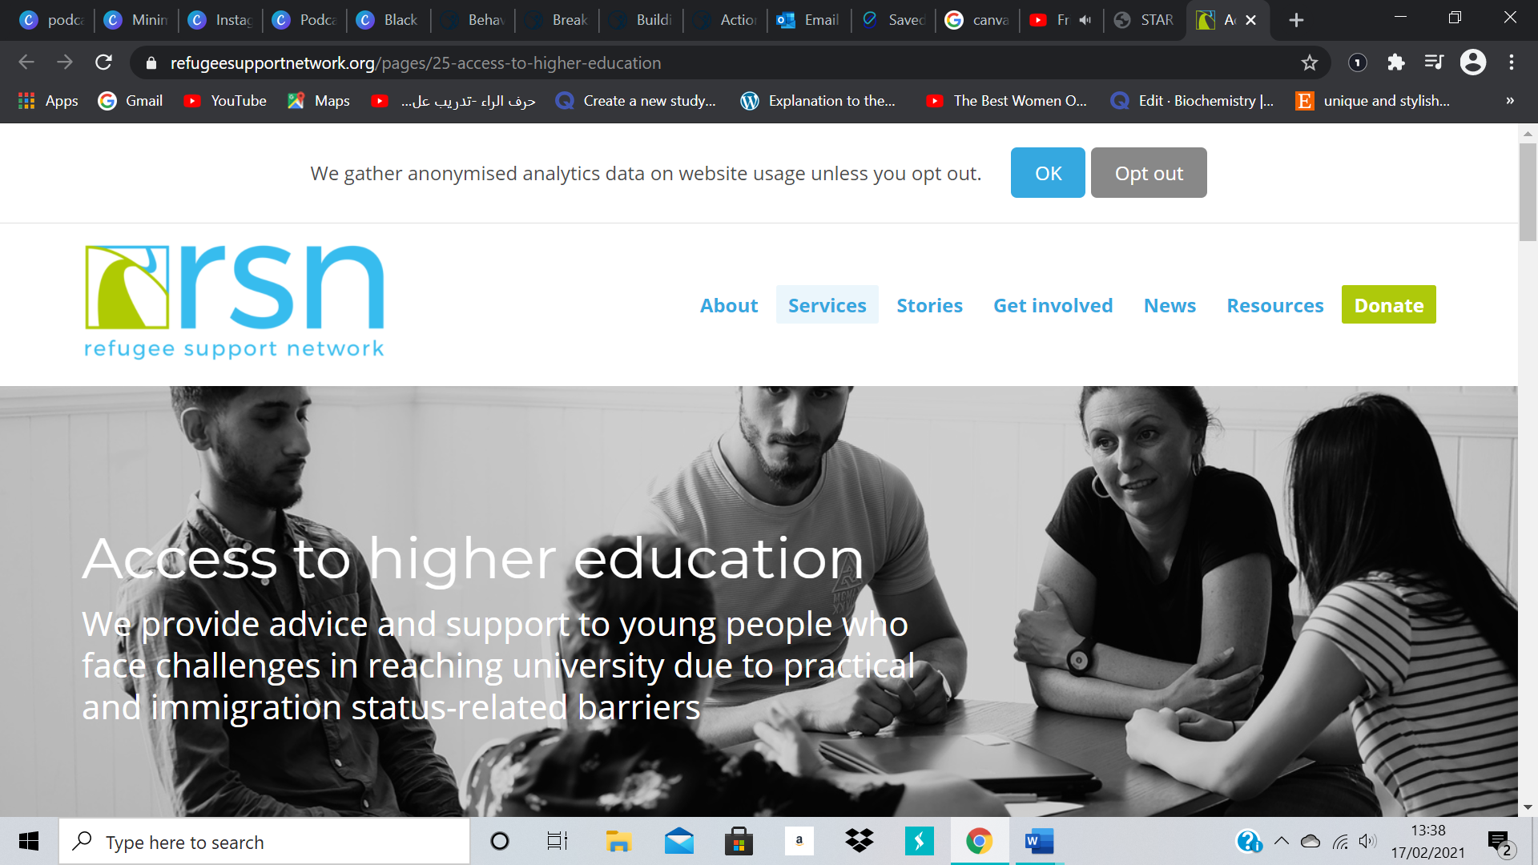

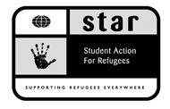[**Access to University**](http://www.star-network.org.uk/index.php/resources/access_to_university)

Student Action for Refugees (STAR) provides a list of Universities in the UK that offer scholarships, bursaries, fee waivers and reduced fees to support people who are refugees and asylum seekers to access higher education. There is also information on other organisations that can provide financial support and grants.

[**Access to Higher Education Advice**](https://www.refugeesupportnetwork.org/pages/25-access-to-higher-education)

Refugee Education UK (REUK) provide support and advice for young people who want to go University but having been finding it difficult to immigration status and practical barriers. The advice offered can be through email, messaging through WhatsApp or face to face support. There is a variety of toolkits and resources for the young people and professionals. REUK also offer individual educational mentoring for young people in several locations in the UK.

[**Transitioning through the education system**](https://www.refugeesupportnetwork.org/resources/23-transitioning-through-education-for-young-refugees-and-asylum-seekers-in-the-uk)

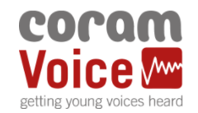A collection of key resources collated from Refugee Support Network and UNICEF UK. There are various advice sheets and research report to provide information to professionals on how to aid young refugees and asylum seekers transition through the education system.

Coram Children’s Legal Centre’s [factsheets on education](https://www.childrenslegalcentre.com/?sfid=132&_sft_resource_topic=education&_sft_resource_type=fact-sheets) including compulsory, further and higher education.

[**Refugee Council**](https://www.refugeecouncil.org.uk/wp-content/uploads/2020/03/Further_Education_September_2017.pdf) Short guide on access to further education in England for asylum seekers and refugees

[**REUK**](https://www.reuk.org/fefaq-asylum) Detailed guidance on asylum seekers entitlements to further education.

[**Oxfordshire County Council**](https://www.oxfordshire.gov.uk/residents/schools/our-work-schools/virtual-school-looked-after-children-and-care-leavers-0-25/asylum-seeker-children) materials to support the educational provision of unaccompanied asylum seeking children as referenced in the UASC handbook. Includes practical strategies and guidance for teachers on how to support pupils new to English.

## Local Authority Support

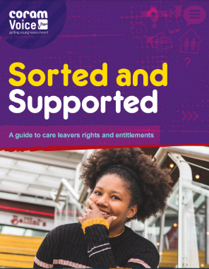The National Transfer Scheme (NTS) protocol for unaccompanied asylum seeking children (UASC, and mainly referred to in this document as unaccompanied children) has been created to enable the safe transfer of unaccompanied children in the UK from one local authority (the entry authority from which the unaccompanied child transfers) to another local authority1 (the receiving authority). Only unaccompanied children that meet the definition of a UASC, as set out in paragraph 352ZD of the Immigration Rules, are eligible to be referred to the NTS

[**Coram Voice**](https://coramvoice.org.uk/)

Coram Voice – ‘Always heard’ is the slogan for coram voice which gives young people a safe place to go to, to speak to an advisor online about any issues they are facing and to see if solutions can be reaches.



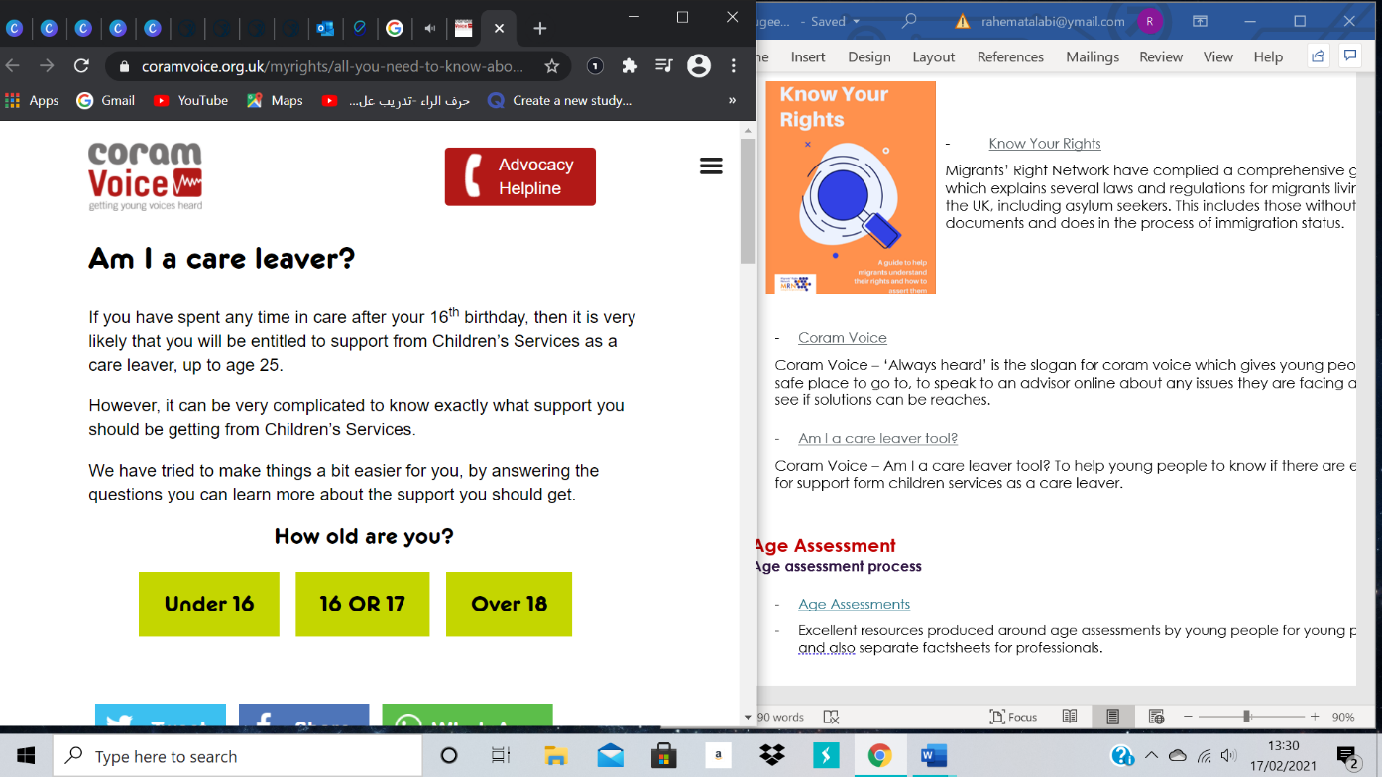

[**Am I a care leaver interactive tool?**](https://coramvoice.org.uk/myrights/all-you-need-to-know-about-leaving-care/i-am-care-leaver/)

Coram Voice – Am I a care leaver tool? To help young people to know if there are eligible for support form children services as a care leaver.

[**Sorted and Supported Guide**](https://coramvoice.org.uk/wp-content/uploads/2020/10/1870-CV-SortedSupported-Guide-new2.pdf)

Helping young care leavers to understand different terminology e.g. former relevant child and what this means for their rights and entitlements

## Journeys to the UK

**Films, TV series and books that provide an insight into the journeys of asylum seekers and refugees**

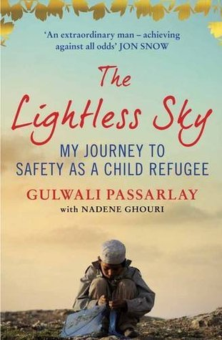 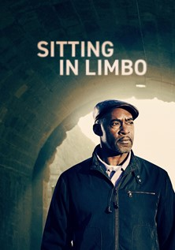 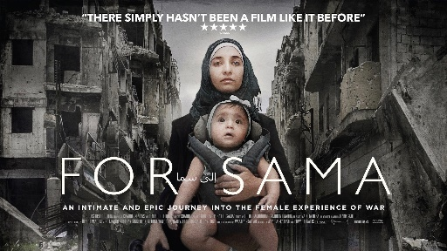 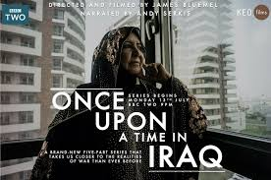

**Sitting In Limbo** (BBC) - drama inspired by the Windrush scandal. This offers a good insight into the asylum process and detention system)

**For Sama** (Channel 4) – documentary about the uprisings in Aleppo, Syria from the perspective of a young female journalist and mother.

**Fire at Sea** (Amazon Prime and Curzon Home Cinema) – ‘Gianfranco Rosi’s incisive, poignant and deeply moving portrait of the Mediterranean island of Lampedusa - and the humanitarian crisis occurring in the seas around it - is both a masterly work of documentary filmmaking and a timely call for urgent action.’

**Once Upon a Time in Iraq** (BBC series) - personal archives from civilians and soldiers from both sides of the conflict.

**Home** (Channel 4) – ‘Comedy series written by and starring Rufus Jones, that deftly gets to the essence of home and family through the eyes of Syrian asylum-seeker Sami’.

**Born In Syria** (Netflix) – ‘This intimate documentary follows a group of Syrian children refugees who narrowly escape a life of torment and integrate into a foreign land.’

**Tears of Salt** by Dr Pietro Bartolo who writes about his running a lone medical clinic on the island of Lampedusa where hundreds of thousands of African and Middle Eastern refugees have travelled through in the hope of making a new life in Europe.

**His House** is a horror film (available on Netflix) about a refugee couple who make a harrowing escape from war-torn South Sudan, but then they struggle to adjust to their new life in an English town that has an evil lurking beneath the surface.

**The Girl from Aleppo**: by Nujeen Mustafa. Inspiring story about Nujeen, a teenager born with cerebral palsy, whose makes it through a harrowing journey from war-ravaged Syria to Germany in a wheelchair.

**The Lightless Sky** by Gulwali Passarlay about his journey from Afghanistan to safety in the UK as an unaccompanied child refugee.

[**Surviving to Thriving​ playlist of short films**](https://www.youtube.com/watch?v=oct1fpLJll0&list=PL_ea5GGKK3gA3NYmKuMHTLSj1soEhbE0a) This is a playlist of 16 short films produced by young people about their experiences on issues such as loneliness, education, prejudice and no right to work. The videos are no longer five minutes long and provide an insight into young people’s experiences in the UK.

## Mental health and wellbeing

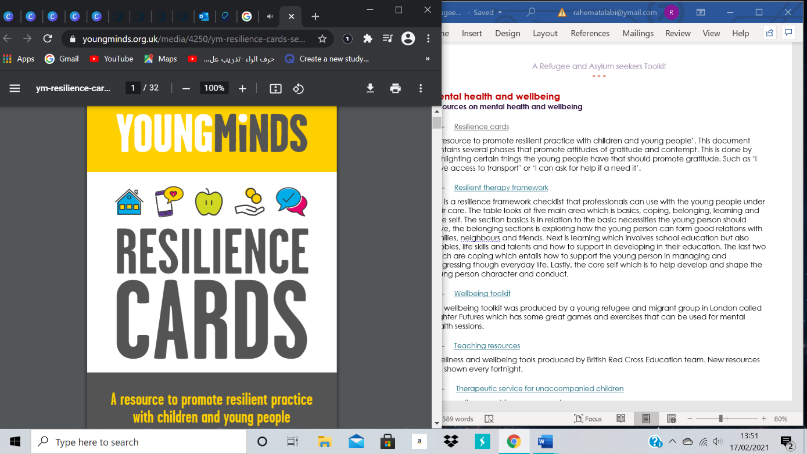

**[Young Minds Resilience cards](https://youngminds.org.uk/media/4250/ym-resilience-cards-secondary-web.pdf)**

‘A resource to promote resilient practice with children and young people’. This document contains several phases that promote attitudes of gratitude and contempt. This is done by highlighting certain things the young people have that should promote gratitude. Such as ‘I have access to transport’ or ‘I can ask for help if a need it’.

**[Resilience Framework](https://www.boingboing.org.uk/wp-content/uploads/2010/10/Resilience-Framework-children-and-young-people-2015.pdf)**

This is a resilience framework checklist that professionals can use with the young people under their care. The table looks at five main area which is basics, coping, belonging, learning and core self. The section basics is in relation to the basic necessities the young person should have, the belonging sections is exploring how the young person can form good relations with families, neighbours and friends. Next is learning which involves school education but also hobbies, life skills and talents and how to support in developing in their education. The last two are about coping which entails how to support the young person in managing and progressing though everyday life. Lastly, the core self which is to help develop and shape the young 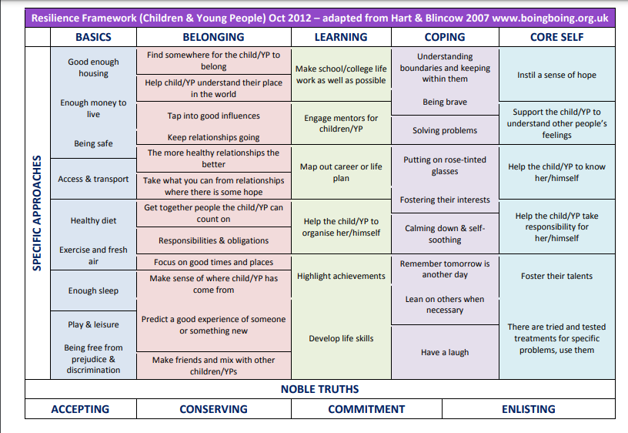person character and conduct.

[**Wellbeing toolkit**](http://www.brighterfutureslondon.co.uk/wellbeingtoolkit/)

This wellbeing toolkit was produced by a young refugee and migrant group in London called Brighter Futures which has some great games and exercises that can be used for mental health and wellbeing individually or in group sessions.

[**BRC Community Education resources**](https://www.redcross.org.uk/get-involved/teaching-resources)

Loneliness and wellbeing tools produced by British Red Cross Education team. New resources are produced every fortnight.

[**UASC Health**](https://www.uaschealth.org/resources/mental-health/sleep-eat-hope/)

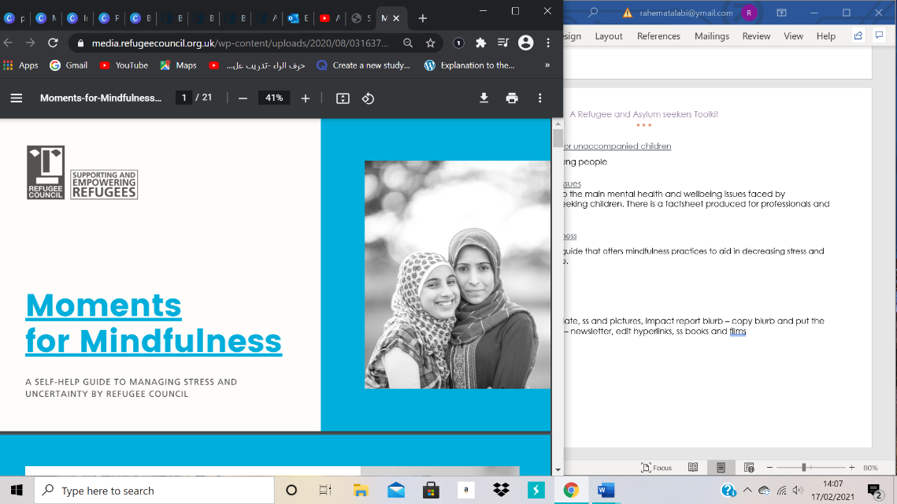Informs and offers advice to the main mental health and wellbeing issues faced by Unaccompanied Asylum-seeking children. Includes Trauma Triangle and Hope.

[**Moments-for-Mindfulness**](https://media.refugeecouncil.org.uk/wp-content/uploads/2020/08/03163730/Moments-for-Mindfulness.pdf)

A mindfulness and self help guide that offers mindfulness practices to aid in decreasing stress and promoting a positive attitude. Can be used individually or within group sessions.

**Mindfulness in Arabic Course**

A free 8-week [mindfulness](https://eur03.safelinks.protection.outlook.com/?url=https%3A%2F%2Fwww.mindfulnessinarabic.org%2Fenglish-course&data=04%7C01%7CYMillican%40redcross.org.uk%7Cf29e389bc55a4d63a16e08d967c800cc%7Cfedc3cbaca5e4388a837b45c7f0d71b7%7C0%7C0%7C637654930966660581%7CUnknown%7CTWFpbGZsb3d8eyJWIjoiMC4wLjAwMDAiLCJQIjoiV2luMzIiLCJBTiI6Ik1haWwiLCJXVCI6Mn0%3D%7C1000&sdata=ucqx8Uhxk5vvwlUbEDGG5sF6ryClRYOh4UJABDJeQ9A%3D&reserved=0) course entirely in Arabic (just click on the “Arabic course” tab under “Course” at the top). All the recordings and resources are on the website and the next sessions become available as you move through so can be completed at your own pace.

## Child Trafficking

## [ECPAT Child Trafficking in the UK 2021](https://www.ecpat.org.uk/Handlers/Download.ashx?IDMF=23b51868-f257-49bc-b779-a5059bd65a04)

ECPAT UK's latest snapshot report on child trafficking provides an overview of the issues affecting children in the UK. Compiling the latest statistics and policy developments, the report highlights never seen before data on immigration outcomes for child victims, secured through Freedom of Information Act requests.

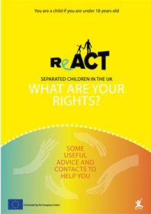[ECPAT's free webinars for professionals](https://www.ecpat.org.uk/news/free-webinars-for-professionals) on a range of child trafficking topics including the statutory defence, trafficked children missing from care and trafficking from Vietnam.

**ReACT** is a partnership project between ECPAT groups in the

UK, France, Belgium, The Netherlands and Germany. They produced this free leaflet to inform child trafficking victims about their rights and how to find help and is available in eleven different languages.

[MICLU Who is Who Guide](https://miclu.org/who-is-who) explains who different professionals are in a separated child’s life in the UK. Available in11 different languages

Range of Toolkits and Resource on [The Children's Society website](https://csepoliceandprevention.org.uk/toolkits) including regarding child criminal exploitation, trafficking, sexual exploitation and county lines.

Coram Children’s Legal Centre [factsheets on trafficking](https://www.childrenslegalcentre.com/?sfid=132&_sft_resource_topic=trafficking) and the National Referral Mechanism process.

[Illegal Money Lending Team, Perception Theatre – Shark Film](https://eur03.safelinks.protection.outlook.com/?url=https%3A%2F%2Fpartnershipforyounglondon.us8.list-manage.com%2Ftrack%2Fclick%3Fu%3Ddca34d06ea32e6e4229821ceb%26id%3D40b865806d%26e%3D672d20072b&data=04%7C01%7CKMcCarthy%40redcross.org.uk%7Ce85d998428464c79c32b08d9089986e3%7Cfedc3cbaca5e4388a837b45c7f0d71b7%7C0%7C0%7C637550277742730030%7CUnknown%7CTWFpbGZsb3d8eyJWIjoiMC4wLjAwMDAiLCJQIjoiV2luMzIiLCJBTiI6Ik1haWwiLCJXVCI6Mn0%3D%7C1000&sdata=EXEz31mN5ynM2O99BVs5s9laLrY9L5mPnYIYwc5eyEg%3D&reserved=0)  
SHARK’ was commissioned by England's Illegal Money Lending Team to help raise awareness and highlight the risks and dangers around illegal money lending and loan sharks. This film is aimed at 14-25 year olds. This project was designed to bring to the foreground and bust the many stereotypes that surround loan sharks, such as who they are and what they look like as well as the ‘types’ of people who borrow money from them.

[Barnados’s Toolkit](https://www.barnardos.org.uk/sites/default/files/2021-04/Barnardos%20Nightwatch%20London%20Toolkit.pdf) for night staff relating to Child exploitation includes a helpful check list

1. **Training and e-modules**

The [**Fostering Across Borders (FAB) Project website**](https://eea.iom.int/fostering-across-borders) contains a range of resources for foster carers including a training manual, information leaflet, videos and five country of origin factsheets.

The International Organisation for Migration (IOM) offers free country information sessions including Syria, Iraq, Sudan, Somalia, DRC, Afghanistan, Kurdish & Eritrea. They also offer sessions on UASC, For more information and to request a session visit [here](https://unitedkingdom.iom.int/refugee-information-sessions)

[**SAFE Project online course**](https://safeproject.eu/elearning-course/) British Red Cross SAFE Project core module and country specific e-modules to enable them to provide better support and meet the needs of unaccompanied and separated children across UK.

[**Future Learn**](https://www.futurelearn.com/courses/caring-for-children-moving-alone)course on ‘Caring for Children Moving Alone: Protecting Unaccompanied and Separated Children’. This course is 100% delivered online.

### [**DisasterReady.Org**](https://ready.csod.com/ui/lms-learning-details/app/material/3c657a20-2062-4e81-a6e4-3d02e01c0047)Supporting Children Who Have Gone Through Difficult Experiences

Protection course online – 4 hours

London local area guides developed by Migrant Rights Network for areas of London including New Cross, Newham, Brent, Hackney, Haringey, and Tower Hamlets. Access [here](https://migrantsrights.org.uk/reports/local-resource-guides/?mc_cid=61407c4905&mc_eid=f0a12c1ee1)!

1. **Reports**

[UNHCR - A Refugee and Then](https://www.unhcr.org/uk/publications/legal/5d271c6a4/a-refugee-and-then.html) - Participatory Assessment of the Reception and Early Integration of Unaccompanied Refugee Children in the UK

[Best Practice Guidance for Social Workers in Wales Supporting UASC](https://childrenslegalcentre.wales/wp-content/uploads/2019/04/06-08-2019_updated_English_child-first-looking-after-unaccompanied-asylum-seeking-children-in-wales.pdf)

[Information for Foster Carers Supporting UASC in Wales](https://childrenslegalcentre.wales/wp-content/uploads/2019/05/child-first-looking-after-asylum-seeking-children-in-wales-foster-carers.pdf)

The Promise - [The-Promise_v7.pdf (carereview.scot)](https://www.carereview.scot/wp-content/uploads/2020/03/The-Promise_v7.pdf)

The Scottish Guardianship Service - [Scottish Guardianship Service - Aberlour](https://www.aberlour.org.uk/services/scottish-guardianship-service/)