**WeMatter Foundations**

*Information for front line staff*

**Benefits of the service:**

WeMatter encourages CYPs to be open-minded towards learning from one another. Discussions are designed to facilitate deep and meaningful conversations; CYPs are empowered to share ideas and coping strategies with each other and these are cultivated and championed further with facilitation from specialist CYP Programme Facilitators.

WeMatter’s group peer support setting provides a good and unique opportunity for CYPs to discuss their emotions and feelings with other CYPs who have experienced domestic abuse. The nature of WeMatter’s trauma-informed support highlights the importance and cathartic benefit of shared lived experiences, allowing CYPs to know they are genuinely not alone in their process of recovery.

With this in mind, WeMatter’s group support framework fosters the growth of healthy relationships between CYPs and amongst their own support networks. WeMatter provides a platform for CYPs to gather and build connections centred on empathy and understanding, equipping them with skills and tools to help them strengthen and formulate healthy relationships elsewhere.

WeMatter enables CYPs to engage with support knowing there is increased anonymity. The methodology of allocation is designed so that CYPs are not in a group with a CYP who attends the same school. Instead, we recognise and find benefit in establishing groups with CYPs from different parts of England.

WeMatter is acutely aware of the barriers towards support for CYPs who do not wish to engage with face-to-face support and CYPs who are neurodivergent. We are proactively committed towards continuing to be a digital support service that is inclusive and accessible to CYPs. Our content is designed and delivered with adaptable activities that cater towards a range of different learning styles (visual, listening and kinaesthetic) and SEND requirements.

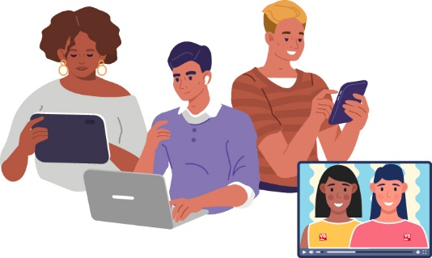**How to make a referral?**

We welcome referrals from professionals, parent and/or carers.

To make a referral please email wematter@victimsupport.uk or contact the WeMatter team on 0300 373 0258 for more information.

**Key things for professionals to remember when talking to service users about WeMatter:**

* Everybody’s experiences of domestic abuse are unique; WeMatter is committed to validating those experiences and fostering a safe space for CYPs to be listened to and respected.
* CYPs who engage with WeMatter may experience a range of emotions and thoughts. That is the aim of the group, to try and help them better understand the link between the thinking, emotions and behaviours they have.
* CYPs who engage with WeMatter will be given an in-depth 1:1 individual assessment before joining their allocated group, this provides an opportunity for the facilitator and CYP to establish a rapport and develop a ‘Working Together Agreement’ which can be catered and tailored to during the duration of support.
* The content is delivered on Zoom via Microsoft PowerPoint, WeMatter regularly review the content to ensure it remains engaging, relevant, age-appropriate and inclusive for CYPs who engage with support.
* Ease of access; group work sessions can be accessed via Zoom on a computer, laptop, tablet and any smartphone device at school, community venue or home where it is safe to do so.
* WeMatter does not disclose CYPs personal experiences of domestic abuse during group support sessions. However, CYPs who wish and feel comfortable to discuss their personal experiences can do so and will be provided opportunities to have a private chat with a CYP Programme Facilitator should they want to discuss such details in greater depth.

**A snapshot of feedback from our WeMatter service users.**

“I really liked the games we played, I liked us working in a team, each of us taking turns to speak and speaking when we wanted to. I really liked the sweets we wrote about ourselves [positive affirmations]. [CYP Programme Facilitator] were amazing! It was really cool and I would give it infinity out of infinity.” - **CYP aged 9yrs**

“Thank you for all your help and support of [CYP], this has been the most impactful exercise/process that we and she has experienced (and we've tried quite a few outlets)” – **CYP aged 13yrs**

“[The CYP Recovery Toolkit] was very helpful and helped get over my problems and anxieties; it helped me find a safe place and safe environment to speak instead of panicking all of the time. I enjoyed talking to the people in the group and speaking to people like yourself who understand what I am going through and making me feel safe enough to talk about it”. – **CYP aged 14yrs**

“There were fun activities, it was a welcoming environment and it was filled with interesting topics that I enjoyed learning about”. – **CYP aged 18\***