Partnership Reduction of Exploitation and Missing

Framework for Screening and Disruption

Date Agreed
Date Launched
Date Review due

CONTENTS

- PREM Flowchart
- PREM Screening
- PREM Assessment and Disruption Planning

1. PREM – Partnership Reduction Exploitation and Missing

Key:

Action
Multi Agency
Early Help
Social Care
Police

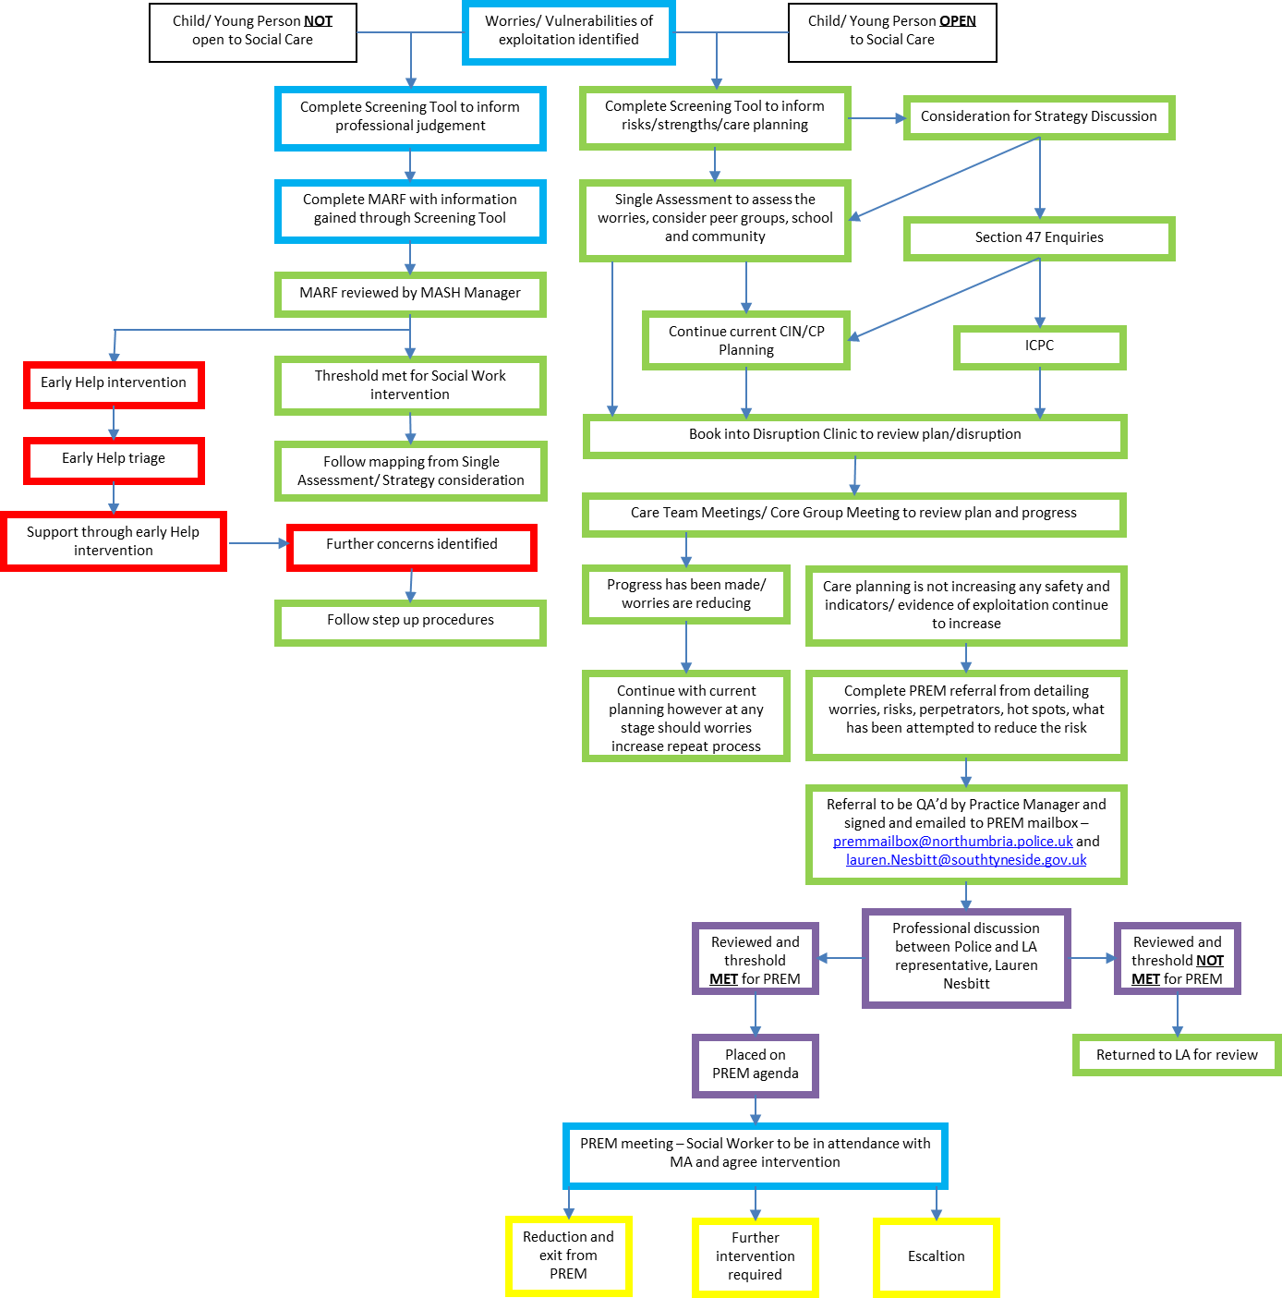

2. PREM Screening

2.1 Any professional who has concerns about exploitation (see below) and harm outside the home of a young person must complete an Exploitation Screening Tool (see below).

2.2 When completing the PREM Screening, safeguarding thresholds should be considered and if they are met, a Multi-Agency Referral Form - South Tyneside Council should be completed, accompanied with the completed PREM Screening document as supporting evidence.

2.3 Where medium risk of exploitation is identified, practitioners must discuss with line managers or safeguarding leads to consider the threshold document in relation to any referral required to either Early Help or Children’s Social Care. When a referral is made, parents/carers’ consent must be gained unless the young person is Fraser/Gillick Competent and is agreeing to work with professionals. If consent is refused, the practitioner should seek advice and support from their line manager.

NB. Consent may be temporarily dispensed with if notifying parents/carers is likely to hinder any investigation or place a young person at risk of harm.

2.4 Young people under 13, young people under 16 years who have not demonstrated Fraser/Gillick competence, those assessed as lacking mental capacity (MCA 2005) associated with exploitation in any area must be assessed as medium or high risk.

2.5 If imminent risk to the young person is identified and/or a crime has been committed, information must immediately be shared with Northumbria Police (999). Information shared for intelligence purposes should be sent to using the following Search: intelligence form to forceintelligence@northumbria.police.uk

2.6 Where concerns relating to radicalisation are identified, professionals should refer to local information regarding Search: prevent which provides details on how to make a referral.

3. Assessment and Disruption Planning

3.1 A Single Assessment and disruption plan must be completed in a multi-agency environment led by a social worker. Before starting the assessment, professionals should check whether consent has been received, as outlined in section 1 above.

3.2 The assessment should:
- identify strengths and concerns by completing the assessment
- include the young person’s and parent’s/carer’s views
- identify diversity issues and how they impact upon safeguarding
- Consider Peer groups, community and school
- identify risk management and disruption
- set out an overall analysis of risk including a balance of strengths, by using professional judgement.

3.3 Where risk is identified within the assessment, an appropriate Safeguarding and Disruption action must also be identified within the plan. Actions should identify:
- ways to safeguarding the individual, recognising them as a victim
- strengths and protective factors
- vulnerability indicators
- consider risk and harm
- disruption activity - see Child Exploitation Disruption Toolkit (GOV.UK toolkit) and civil remedies/disruption (see below)

3.4 Consideration must be given to ensure the safety of the young person when disclosures are made, including reporting crimes and intelligence to police.

3.5 The young person and parents/carers’ views of the risks, assessment and disruption plan are essential.

3.6 Once the Assessment is complete and a draft plan created in collaboration with the child/young person and parents, the social worker will then book into disruption clinic to review the plan and ensure all areas of worries have been considered.

3.7 Should the worries identified continue/or escalate Social Worker should discuss with their Team Manager to consider whether the threshold has been met to refer to PREM. Where it is, the Team Manager will quality assure the PREM referral form and send onto the dedicated mailbox PREMmailbox@northumbria.police.uk.

3.7 If the threshold to refer to PREM is not met, the Social Worker and Team Manager will record their rationale on the LCS care record for the child/young person.

3.8 It is good practice for the Team Manager to record management oversight of the decisions made, within case notes.

